**Labour Market Information**

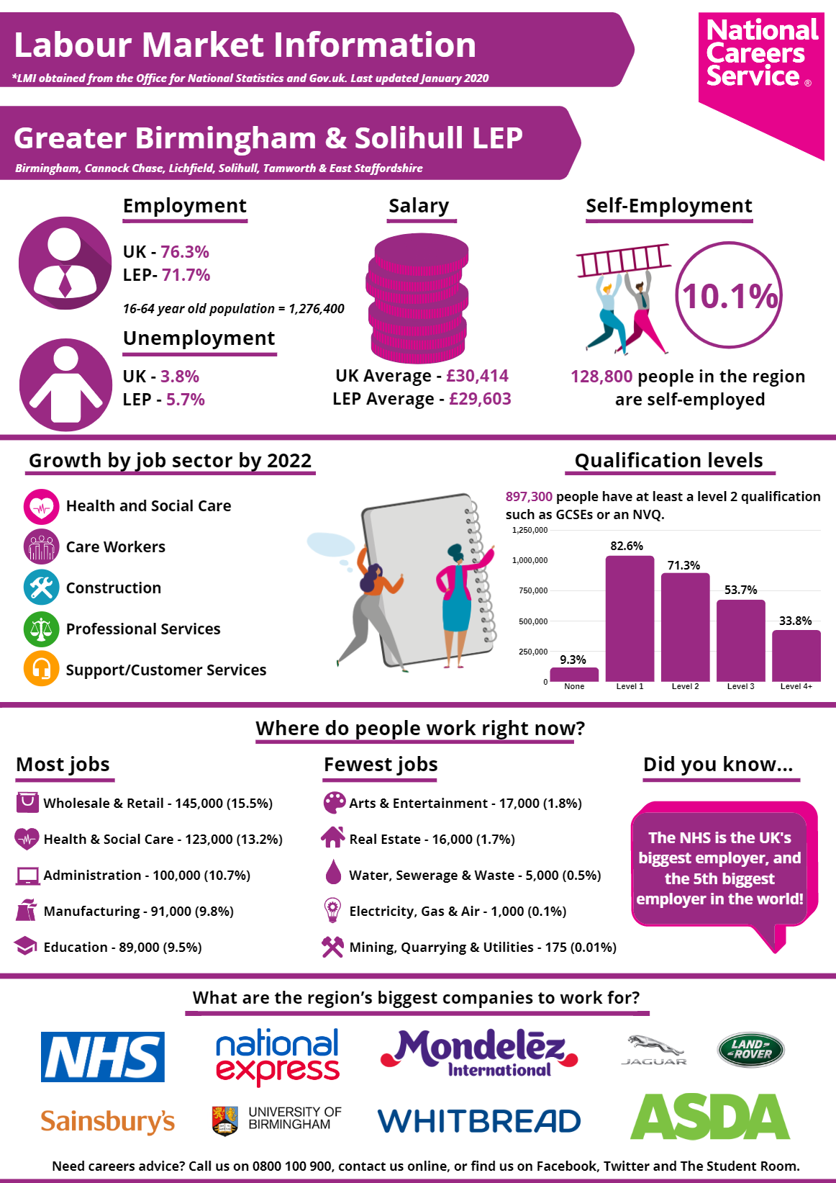

Destination Reports: