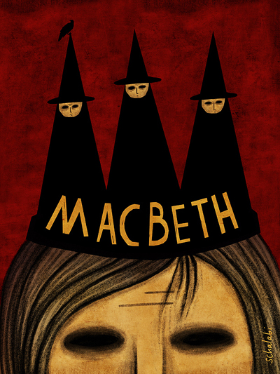

Act One

Name:
Learning goals
Macbeth Summary
Act One | 1.1 Three witches meet on the heath
 | 1.2 Macbeth and Banquo – brave soldiers
 | 1.3 The witches meet Macbeth and Banquo. Macbeth becomes Thane of Cawdor.
 | 1.4 Duncan meets with Macbeth and plans to meet him at the castle.
 | 1.5 Lady Macbeth’s letter. Lady Macbeth convinces Macbeth to kill King Duncan.
 | 1.6 Duncan arrives at Macbeth’s castle.
 | 1.7 Macbeth’s soliloquy. Macbeth tells Lady Macbeth he will not murder Duncan. She convinces him to go ahead with the murder.
Act Two | 2.1 Banquo and Macbeth talk briefly about the witches. Macbeth sees a dagger in front of him.
 | 2.2 Macbeth murders King Duncan. Macbeth’s guilt is apparent. Lady Macbeth feels no guilt.
 | 2.3 Duncan’s dead body is discovered.
 | 2.4 Macbeth becomes king.
Act Three | 3.1 Macbeth questions Banquo. He plans his murder.
 | 3.2 Lady Macbeth and Macbeth talk.
 | 3.3 Banquo is murdered.
 | 3.4 The banquet and Banquo’s ghost.
 | 3.5 Hecate.
 | 3.6 Lennox shares his suspicions about Macbeth.
Act Four | 4.1 The witches share three prophecies as well as sharing a vision of Banquo.
 | 4.2 Macbeth has Macduff’s wife and children murdered.
 | 4.3 Malcolm puts Macduff to the test.
Act Five | 5.1 Lady Macbeth’s sleepwalking.
 | 5.2 The rebels.
 | 5.3 Macbeth is fearless.
 | 5.4 Great Birnam wood rises.
 | 5.5 Lady Macbeth is dead.
 | 5.6 Malcolm prepares for battle.
 | 5.7 Macbeth kills young Siward.
 | 5.8 Macduff kills Macbeth.
 | 5.9 Malcolm is crowned king.

Learning episode 6
Do it now task
Recap questions:
- What has happened to Lady Macbeth and how does Macbeth react?
______________________________________________________________________________________________________________________________________
- How does Macbeth feel ahead of battle and why do you think this is?
______________________________________________________________________________________________________________________________________
- Birnam woods come to Dunsinane. How?
______________________________________________________________________________________________________________________________________
- Who comes to fight Macbeth and how is he able to kill him if no man born of a woman can?
______________________________________________________________________________________________________________________________________
- Who is crowned king at the end of the play?
______________________________________________________________________________________________________________________________________
New knowledge
AO3
Context
Witches and Witchcraft in Shakespeare’s Time
Credited to Rob Ward
1 | Throughout the ages there have been people who have believed
2 | in witches and witchcraft. The people of Shakespeare’s day
3 | were no different. Shakespeare drew on the popular traditions
4 | of his time and used them for his own purposes. In Macbeth,
5 | he used popular beliefs about witches and witchcraft.
6 | When Shakespeare wrote Macbeth, witchcraft was a topic of
7 | considerable interest. A Jacobean audience would have taken
8 | witches very seriously. Witches were considered to be political
9 | and spiritual traitors who disturbed the natural order of things.
10 | In 1597, the new king of England, James I, wrote a book
11 | called Demonology – a study of witchcraft and its evils and
12 | tightened up laws against witchcraft in 1604, passing a statute
13 | where anyone exercising witchcraft ‘shall suffer pains of death
14 | as a felon or felons, and shall lose the privilege and benefit of
15 | clergy and sanctuary.’ James was convinced that a group of
16 | witches had raised a storm and tried to drown him and, as a
17 | result, considered the works of the devil.
18 | Perhaps due to the new King’s influence not only were witches
19 | blamed for ‘bad’ things, but they also became victims of violent
20 | persecution. Witch-Hunts were extremely popular between
21 | 1560 and 1632 across England and Scotland. During this time,
22 | hundreds of thousands of women were tortured and killed
23 | because they were accused of witchcraft.
24 | Evidence of a relationship with evil spirits condemned a
25 | suspect to death by hanging, burning or drowning so for a king
26 | like Macbeth to have dealings with witches would have seemed
27 | both a crime and a sin.
28 | Witches were supposed to be capable of doing all the things that
29 | the three weird sisters are said to perform in Macbeth. It was
30 | believed that they could see into the future; that they could
31 | create storms, hail, thunder and lightning; stop the sun and
32 | change night into day and day into night. In order to work their
33 | charms, they would open graves and steal parts of the bodies
34 | to make potions. For this purpose, the bodies of unbaptized
35 | babies were especially prized. And witches could call up the
36 | dead.
37 | Macbeth is easily captured by their power and by their
38 | prophecies. But note that they never tell him a lie. However,
39 | they do allow him to deceive himself. The devil does not lie…
40 | but leads us into temptation.

Pen to paper
Identify a minimum of three things you have learnt about how witches were viewed during Shakespeare’s time.
_______________________________________________________________________________________________________________________________________________________________________________________________________________________________________________________________________________________________________________________________________________
New knowledge
Now let’s read the opening scene to Macbeth.
Macbeth Act 1 Scene 1. A desert place.
Thunder and Lightning. Enter three witches.
 | First Witch
1 | When shall we three meet again
2 | In thunder, lightning, or in rain?
 | Second Witch
3 | When the hurlyburly’s done,
4 | When the battle’s lost and won.
 | Third Witch
5 | That will be ere the set of sun.
 | First Witch
6 | Where the place?
 | Second Witch
7 | Upon the heath.
 | Third Witch
8 | There to meet with Macbeth
 | First Witch
9 | I come, Graymalkin!
 | Second Witch
10 | Paddock calls.
 | Third Witch
11 | Anon.
 | ALL
12 | Fair is foul, and foul is fair:
13 | Hover through the fog and filthy air.

Pen to paper
Aside from the obvious, what evidence is there to suggest we are being introduced to witches in the opening scene?
_________________________________________________________________________________________________________________________________________________________________________________________________________

New knowledge

The methods Shakespeare uses to present the witches
In part (a) of the Macbeth examination, you will be asked to write about how Shakespeare has used language, structure and form to present a character, a theme or a moment. In today’s lesson we are going to look at the methods Shakespeare has used to present the witches.
Part A
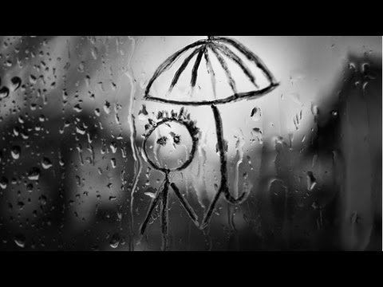 | 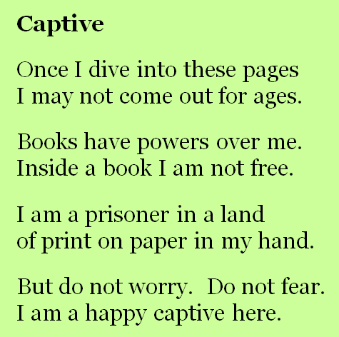 | 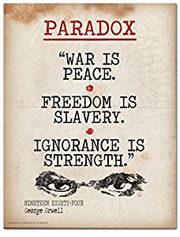
What is pathetic fallacy? | What are rhyming couplets? | What is a paradox?

Pen to paper
- Pathetic fallacy
Re-read Act 1 Scene 1. What references to the weather can you find? How does the use of pathetic fallacy contribute to the mood at the start of the play? How does its usage connect to what we have learnt about witches during this time?

_______________________________________________________________________________________________________________________________________________________________________________________________________________________________________________________________________________________________________________________________________________

- Rhyming couplets
The witches often speak in rhyming couplets. Identify one rhyming couplet from Act 1 Scene 1. When are rhyming couplets mostly used and why?

______________________________________________________________________________________________________________________________________________________________________________________________________________________________________________________________________________________________________________________________________________

- A paradox
A paradox is used at the end of the first scene: ‘Fair is foul and foul is fair.’ This paradox sets up one of the key themes in the play. What do you think this paradox means? Why do you think it is the witches who set this up?

_______________________________________________________________________________________________________________________________________________________________________________________________________________________________________________________________________________________________________________________________________________
Reflection

How has Shakespeare used language OR / AND structure to present the witches at the start of Act 1 Scene 1?

 | Technique | What technique has been used to present the witches at the start of Act 1 Scene 1?
 | Example | Can you find an example of where this technique features?  This is evident in the line…
 | Explanation | What does this line tell you about the witches?  This line tells me…
 | Exploration | How does the use of the technique enhance our understanding of the characters?  The use of ____ suggests…
 | Effect | What would an audience think as a result?  An audience would…

Formative assessment: Copy the question above into your formative assessment book and then write your response to the question, using the grid above to help you, underneath.

Learning episode 7
Do it now task
Recap questions:
- Identify three things you learnt about witches during Shakespeare’s time in the last learning episode.
_________________________________________________________________________________________________________________________________________________________________________________________________________
- Where are the witches and what is the weather doing?
______________________________________________________________________________________________________________________________________
- Who are they looking to meet when war is over and where will they meet him?
______________________________________________________________________________________________________________________________________
- What is pathetic fallacy?
______________________________________________________________________________________________________________________________________
- What are rhyming couplets?
______________________________________________________________________________________________________________________________________
- What is a paradox?
______________________________________________________________________________________________________________________________________
- What does the line ‘fair is foul, and foul is fair’ mean?
_________________________________________________________________________________________________________________________________________________________________________________________________________
Challenge: Finish these sentence openers.
- While modern audiences might consider the witches exaggerated or absurd caricatures, a Jacobean audience would have believed
____________________________________________________________________________________________________________________________________________________________________________________________________________________________________________________________________________
- Shakespeare’s use of rhyming couplets for the witches’ speech suggests
____________________________________________________________________________________________________________________________________________________________________________________________________________________________________________________________________________
- The supernatural in Macbeth
____________________________________________________________________________________________________________________________________________________________________________________________________________________________________________________________________________

- The witches could be seen as agents of fate who
____________________________________________________________________________________________________________________________________________________________________________________________________________________________________________________________________________

Pen to paper
In the space below record your responses to the following two questions: What is a hero and what does someone have to do in order to be labelled ‘heroic’?

New knowledge
In today’s lesson, we are going to read Act 1, Scene 2 which is where we are introduced to Macbeth and Banquo for the first time who have been busy on the battlefield. Read through the interesting facts about what it meant to be a soldier during this time.
1 | Military service was not optional for men, whether of nobility or
2 | a commoner; it was considered a duty to both king and God.
3 | The Divine Right of Kings meant a war initiated by the throne
4 | was approved of by God; therefore, a good subject was obliged
5 | to take up arms in defence of both God and king, and to kill in
6 | their names.
7 | Bravery on the battlefield made you a military and a Christian
8 | hero.
9 | Soldiers were rewarded though: nobles took a share of spoils, a
10 | common solider would be paid.
11 | As a show of power, it was also common for soldiers to destroy
12 | and pillage an area invaded. Soldiers were feared for their
13 | potential for brutality.

New knowledge
Let’s read Act 1, Scene 2 in which we learn about Macbeth and Banquo’s performance on the battlefield.
 | Scene II. A camp near Forres.
 | Alarum within. Enter DUNCAN, MALCOLM, DONALBAIN, LENNOX, with Attendants, meeting a bleeding Sergeant.
 | DUNCAN
1 | What bloody man is that? He can report
2 | As seemth by his plight, of the revolt
3 | The newest state.
 | MALCOLM
4 | This is the sergeant
5 | Who like a good and hardy soldier fought
6 | ‘Gainst my capitivity. Hail, brave friend!
7 | Say to the king the knowledge of the broil
8 | As thou didst leave it.
 | SERGEANT
9 | Doubtful it stood;
10 | As two spent swimmers, that do cling together
11 | And choke their art. The merciless Macdonwald -
12 | Worthy to be a rebel, for to that
13 | The multiplying villainies of nature
14 | Do swarm upon him – from the western isles
15 | Of kerns and gallowglasses is supplied;
16 | And fortune, on his damned quarrel smiling,
17 | Show’d like a rebel’s whore: but all’s too weak:
18 | For brave Macbeth – well he deserves that name -
19 | Disdaining fortune, with his brandish’d steel,
20 | Which smoked with bloody execution,
21 | Like valour’s minion carved out his passage
22 | Till he faced the slave;
23 | Which ne’er shook hands, nor bade farewell to him,
24 | Till he unseam’d him from the nave to the chaps,
25 | And fix’d his head upon our battlements.
 | DUNCAN
26 | O valiant cousin! O worthy gentleman!
 | SERGEANT
27 | As whence the sun ‘gins his reflection
28 | Shipwrecking storms and direful thunders break,
29 | So from that spring whence comfort seem’d t come
30 | Discomfort swells. Mark, king of Scotland, mark:
31 | No sooner justice had with valour arm’d
32 | Compell’d these skipping kerns to trust their heels,
33 | But the Norweyan lord surveying vantage,
34 | With furbish’d arms and new supplies of men
35 | Began a fresh assault.
 | DUNCAN
36 | Dismay’d not this
37 | Our captains, Macbeth and Banquo?
 | SERGEANT
38 | Yes;
39 | As sparrows eagles, or the hare the lion.
40 | If I say sooth, I must report they were
41 | As cannons overcharged with double cracks, so they
42 | Doubly redoubled strokes upon the foe:
43 | Except they meant to bathe in reeking wounds,
44 | Or memorise another Golgotha,
45 | I cannot tell.
46 | But I am faint, my gashes cry for help.
 | DUNCAN
47 | So well thy words become thee as thy wounds;
48 | They smack of honour both. Go get him surgeons.
 | Exit Sergeant, attended.
49 | Who comes here?
 | Enter Ross
 | MALCOLM
50 | The worthy thane of Ross.
 | LENNOX
51 | What a haste looks through this eyes! So should he look
52 | That seems to speak things strange.
 | ROSS
53 | God save the king!
 | DUNCAN
54 | Whence camest thou, worthy thane?
 | ROSS
55 | From Fife, great king;
56 | Where the Norweyan banners flout the sky
57 | And fan our people cold. Norway himself,
58 | With terrible numbers,
59 | Assisted by that most disloyal traitor
60 | The thane of Cawdor, began a dismal conflict;
61 | Till that Bellona’s bridegroom, lapp’d in proof,
62 | Confronted him with self-comparisons,
63 | Point against point rebellious, arm ‘gainst arm.
64 | Curbing his lavish spirit: and, to conclude,
65 | The victory fell on us.
 | DUNCAN
66 | Great happiness!
 | ROSS
67 | That now
68 | Sweno, the Norways’ king, craves composition:
69 | Nor would we deign him burial of his men
70 | Till he disbursed at Saint Colme’s inch
71 | Ten thousand dollars to our general use.
 | DUNCAN
72 | No more that thane of Cawdor shall deceive
73 | Our bosom interest: go pronounce his present death,
74 | And with his former title greet Macbeth.
 | ROSS
75 | I’ll see it done.
 | DUNCAN
76 | What he hath lost noble Macbeth hath won.

Pen to paper
Key task: In the extract above, we learn about the character of Macbeth. In today’s lesson we are going to focus on how this character is presented to us.
Re-read the extract from Act 1 Scene 2 and identify what is said about Macbeth.
Use the chart on the following page to record what the captain, Duncan and Ross all say about Macbeth.
Can you identify how Shakespeare has crafted language to present Macbeth in each utterance? What techniques has he used?
Hint: the following techniques have been used – adjectives, verbs, simile, nouns, allusion.
How has the use of the language technique helped to present the character of Macbeth? Why do you think Shakespeare chose that particular technique? What do you think he wanted to convey to the audience and why?

How has Shakespeare presented the character of Macbeth at the start of the play?
The captain |  |  | Duncan |  |  | Ross
Quotation | What do we learn from the quotation and what language technique has been used? | How is the use of this word / technique meant to affect our thoughts on Macbeth? | Quotation | What do we learn from the quotation and what language technique has been used? | How is the use of this word / technique meant to affect our thoughts on Macbeth? | Quotation | What do we learn from the quotation and what language technique has been used? | How is the use of this word / technique meant to affect our thoughts on Macbeth?

Pen to paper
Once you have completed the chart, look at the following paragraph which explores the use of adjectives to present Macbeth.

Adjectives have been used to present the character of Macbeth at the start of Act 1. This is evident when the captain says ‘For brave Macbeth’ which tells us Macbeth is courageous. The use of the adjective ‘brave’ suggests to the audience that the captain respects and admires Macbeth and the fearless approach he has shown during the war. At this point, an audience would view Macbeth as one of Duncan’s best soldiers. However, presenting Macbeth as ‘brave’ at the start might seek to only emphasise how great his downfall was later on and reinforce the notion that ‘fair is foul, and foul is fair’ and perhaps we, as an audience, cannot trust everything we see.

Key task: How does this student meet the AOs?

Now it is your turn! Copy the following question into your formative assessment book and then use the grid below to help you write a response.
How has Shakespeare constructed Macbeth’s identity at the start of the play using a range of language techniques?
 | Technique | What technique has been used to present Macbeth at the start of the play?
 | Example | Can you find an example of where this technique features?  This is evident in the line…
 | Explanation | What does this line tell you about how Macbeth is viewed?  This line tells me…
 | Exploration | How does the use of the technique enhance our understanding of how others view Macbeth?  The use of ____ suggests…
 | Effect | What would an audience think as a result?  An audience would…

Reflection
In Act 1 Scene 2 Shakespeare uses the speeches of other characters to establish Macbeth’s reputation, rather than introducing the character to the audience directly. Why might he have chosen to introduce Macbeth in this way? What effect does it have?
________________________________________________________________________________________________________________________________________________________________________________________________________________________________________________________________________________________________________________________________________________________________________________________________________________________________________________________________________________________________________________________________________________________

Part B | At the start of Act 1 Scene 3, the witches are gathered together waiting for Macbeth and Banquo to return from battle. One witch tells the others about how she has been rebuked by a sailor’s wife and as a result has cast a spell on the sailor to get her revenge.  Task: Read the extract below:

 | A heath near Forres.
 | Thunder. Enter the three Witches.
 | FIRST WITCH
1 | Where hast thou been, sister?
 | SECOND WITCH
2 | Killing swine.
 | THIRD WITCH
3 | Sister, where thou?
 | FIRST WITCH
4 | A sailor’s wife had chestnuts in her lap,
5 | And munch’d, and munch’d, and munch’d:-
6 | ‘Give me,’ quoth I:
7 | ‘Aroint thee, witch!’ the rump-fed ronyon cries.
8 | Her husband’s to Aleppo gone, master o’ the Tiger:
9 | But in a sieve I’ll thither sail,
10 | And, like a rat without a tail,
11 | I’ll do, I’ll do, and I’ll do.
 | SECOND WITCH
12 | I’ll give thee a wind.
 | FIRST WITCH
13 | Thou’rt kind.
 | THIRD WITCH
14 | And I another.
 | FIRST WITCH
15 | I myself have all the other,
16 | And the very ports they blow,
17 | All the quarters that they know
18 | I’ the shipman’s card.
19 | I will drain him dry as hay;
20 | Sleep shall neither night nor day
21 | Hang upon his pent-house lid;
22 | He shall live a man forbid:
23 | Weary se’nnights nine times nine
24 | Shall he dwindle, peak and pine:
25 | Though his bark cannot be lost,
26 | Yet it shall be tempest-tost.
27 | Look what I have.
 | SECOND WITCH
28 | Show me, show me.
 | FIRST WITCH
29 | Here I have a pilot’s thumb,
30 | Wreck’d as homeward he did come.
 | Drum within
 | THIRD WITCH
31 | A drum, a drum!
32 | Macbeth doth come.
 | ALL
33 | The weird sisters, hand in hand,
34 | Posters of the sea and land,
35 | Thus do go about, about:
36 | Thrice to thine and thrice to mine
37 | And thrice again, to make up nine.
38 | Peace! The charm’s wound up.

Key questions: remember to answer these questions using full sentences.
- Can you identify a reference to the weather? Why do we associate this weather with the witches?
______________________________________________________________________________________________________________________________________
- What has the second witch been doing at the start of the scene?
___________________________________________________________________
- Who did the first witch meet? What did she ask for? How did the person respond?
______________________________________________________________________________________________________________________________________ ___________________________________________________________________
- From lines 8-27, what do we learn the first witch did as a result?
____________________________________________________________________________________________________________________________________________________________________________________________________________________________________________________________________________
- Rhyming couplets have been used here to present the witches. Identify an example of rhyming couplets and explain why Shakespeare has used rhyming couplets to present the witches?
_________________________________________________________________________________________________________________________________________________________________________________________________________
- How does the presentation of the witches at the start of Act 1 Scene 3 support your contextual understanding of witches during Shakespeare’s time?
____________________________________________________________________________________________________________________________________________________________________________________________________________________________________________________________________________
- How does the presentation of witches in this scene compare to the presentation of witches in the opening scene?
_________________________________________________________________________________________________________________________________________________________________________________________________________

Learning episode 8
Do it now task
Recap questions:
- What two adjectives does Malcolm use in line 5 to describe Macbeth?
___________________________________________________________________
- What evidence is there between lines 18-25 that Macbeth is a brave and heroic soldier?
____________________________________________________________________________________________________________________________________________________________________________________________________________________________________________________________________________
- How does Duncan respond to this news on line 26?
______________________________________________________________________________________________________________________________________
- Identify a simile used to describe Macbeth and Banquo in battle between lines 38-46 and explain what we can infer about them from this.
____________________________________________________________________________________________________________________________________________________________________________________________________________________________________________________________________________
- Who has betrayed the king and what has happened as a result?
______________________________________________________________________________________________________________________________________
- Why is Macbeth compared to Bellona?
______________________________________________________________________________________________________________________________________

Challenge: Metonymy is a figure of speech that replaces the name of something else with which it is closely associated.
- England decides to keep check on immigration (England refers to the government.)
- The pen is mightier than the sword. (Pen refers to written words and sword to military force.)
- Let me give you a hand. (Hand means help.)

Metonymy is used in the following line spoken by King Duncan: ‘No more that Thane of Cawdor shall deceive.’

Metonymy is all about removing individual identity. It takes personal importance out of the equation and in Macbeth emphasises the importance of a role. Duncan’s use of metonymy shows that the Thaneship holds more importance to him than the individuals in the role. In this instance, Duncan does not refer to man who was the Thane of Cawdor, he seemingly disrespects him by not acknowledging him as a person. Yet – ironically – by using metonymy and referring to his role, Duncan sets up the idea that it is the title ‘Thane of Cawdor’ that is deceptive. These ‘borrowed robes’ which Macbeth receives are symbolically tainted with betrayal.

Key question: How far could we argue, therefore, that Duncan is partially responsible for the actions Macbeth takes later on?
________________________________________________________________________________________________________________________________________________________________________________________________________________________________________________________________________________________________________________________________________________________________________________________________________________________________________________________________________________________________________________________________________________________

New knowledge
Read the text below about ‘fate’.
AO3
Context
1 | In Shakespeare’s time, it was commonly believed that one’s life
2 | was predestined. Even though it was believed that life was
3 | predestined that did not mean that humans did not have free
4 | will to make the right moral and religious choices. The key
5 | question in Macbeth is the extent to which his actions are
6 | controlled by fate (in this case the witches) and the extent to
7 | which he makes evil choices using his own free will.
8 | In Act 1 Scene 3, the witches refer to themselves as ‘the weird
9 | sisters.’ This is not the modern meaning of weird which is
10 | ‘peculiar or strange.’ The word comes from the Anglo-Saxon
11 | word for fate – ‘wyrd.’ The suggestion is that the witches can
12 | control human destiny.
13 | In the Middle Ages particularly, but also later in the Elizabethan
14 | times it was widely believed that Fate (or Fortune) was the main
15 | controlling force in life. In Shakespeare’s time, tragedy was
16 | perceived as a reversal of fortune; a fall from a high position.
17 | This view of tragedy derives from the Medieval concept of
18 | fortune, which was personified as Fortuna, a blindfolded woman
19 | who turned a wheel at whim. Men were stationed at various
20 | places on the wheel – the top of the wheel represented the best
21 | fortune and under the wheel the worst. However, the wheel
22 | could turn suddenly and the man on top could unexpectedly
23 | find himself under the wheel, without warning.
Key question: to what extent do you believe in fate?
_______________________________________________________________________________________________________________________________________________________________________________________________________________________________________________________________________________________________________________________________________________
New knowledge
In this learning episode, we are going to continue our reading of Macbeth, with a focus on Act 1 Scene 3.
 | Enter MACBETH and BANQUO
 | MACBETH
38 | So foul and fair a day I have not seen.
 | BANQUO
39 | How far is’t call’d to Forres? What are these
40 | So wither’d and so wild in their attire,
41 | That look not like the inhabitants o’ the earth,
42 | And yet are on’t? Live you? Or are you aught
43 | That man may question? You seem to understand me,
44 | By each at once her chappy finger laying
45 | Upon her skinny lips: you should be women,
46 | And yet your beards forbid me to interpret
47 | That you are so.
 | MACBETH
48 | Speak, if you can: what are you?
 | FIRST WITCH
49 | All hail, Macbeth! Hail to thee, thane of Glamis!
 | SECOND WITCH
50 | All hail, Macbeth! Hail to thee, thane of Cawdor!
 | THIRD WITCH
51 | All hail, Macbeth, thou shalt be king hereafter!
 | BANQUO
52 | Good sir, why do you start; and seem to fear
53 | Things that do sound so fair? I’ the name of truth,
54 | Are ye fantastical, or that indeed
55 | Which outwardly ye show? My noble partner
56 | You greet with present grace and great prediction
57 | Of noble having and of royal hope,
58 | That he seems rapt withal: to me you speak not.
59 | If you can look into the seeds of time,
60 | And say which grain will grow and which will not,
61 | Speak then to me, who neither beg nor fear
62 | Your favours nor your hate.
 | FIRST WITCH
63 | Hail!
 | SECOND WITCH
64 | Hail!
 | THIRD WITCH
65 | Hail!
 | FIRST WITCH
66 | Lesser than Macbeth, and greater.
 | SECOND WITCH
67 | Not so happy, yet much happier.
 | THIRD WITCH
68 | Thou shalt get kings, though thou be none:
69 | So all hail, Macbeth and Banquo!
 | FIRST WITCH
70 | Banquo and Macbeth, all hail!
 | MACBETH
71 | Stay, you imperfect speakers, tell me more:
72 | By Sinel’s death I know I am thane of Glamis;
73 | But how of Cawdor? The thane of Cawdor lives,
74 | A prosperous gentleman; and to be king
75 | Stands not within the prospect of belief,
76 | No more than to be Cawdor. Say from whence
77 | You owe this strange intelligence? Or why
78 | Upon this blasted heath you stop our way
79 | With such prophetic greeting? Speak, I charge you.
 | Witches vanish
 | BANQUO
80 | The earth hath bubbles, as the water has,
81 | And these are of them. Whither are they vanish’d?
 | MACBETH
82 | Into the air; and what seem’d corporal melted
83 | As breath into the wind. Would they had stay’d!
 | BANQUO
84 | Were such things here as we do speak about?
85 | Or have we eaten on the insane root
86 | That takes the reason prisoner?
 | MACBETH
87 | Your children shall be kings.
 | BANQUO
88 | You shall be king.
 | MACBETH
89 | And thane of Cawdor too: went it not so?
 | BANQUO
90 | To the selfsame tune and words. Who’s here?

Pen to paper
After reading Act 1 Scene 3, complete the activities on the next few pages to explore Macbeth and Banquo’s reactions to the witches and the prophecies they share.

‘So foul and fair a day I have not seen’
Which of these statements do you agree with? | True / False | Support
Macbeth is referring to the weather.
Macbeth is referring to their recent success in the battle.
Macbeth’s comment is in reference to the light.
Macbeth’s meaning is unclear. Like the witches he is speaking in riddles.
Key questions: Where have you seen a similar line before? What do you think Shakespeare is trying to do as a result?

How do Banquo and Macbeth describe the witches?
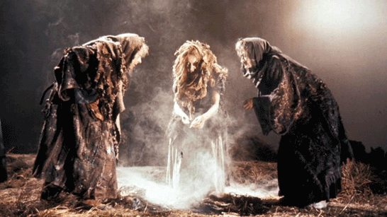
Look at the following statements – which are said to Macbeth and which are said to Banquo?
 |  |  | Macbeth | Banquo
You will be king.
Your title is Thane of Glamis.
Your children will be kings, but you won’t.
You are not going to be as happy as your friend in one way, but in another way you will be much happier.
You are getting a new title, Thane of Cawdor.
You’re not as important as your friend but in another way you are more important.

How does Macbeth respond to the witches’ prophecies? | How does Banquo respond to the witches’ prophecies? | What does Banquo say about Macbeth and the effect the witches seem to have had on him?
Chosen quotations:  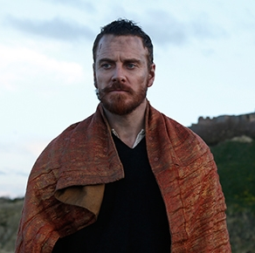 | Chosen quotations:  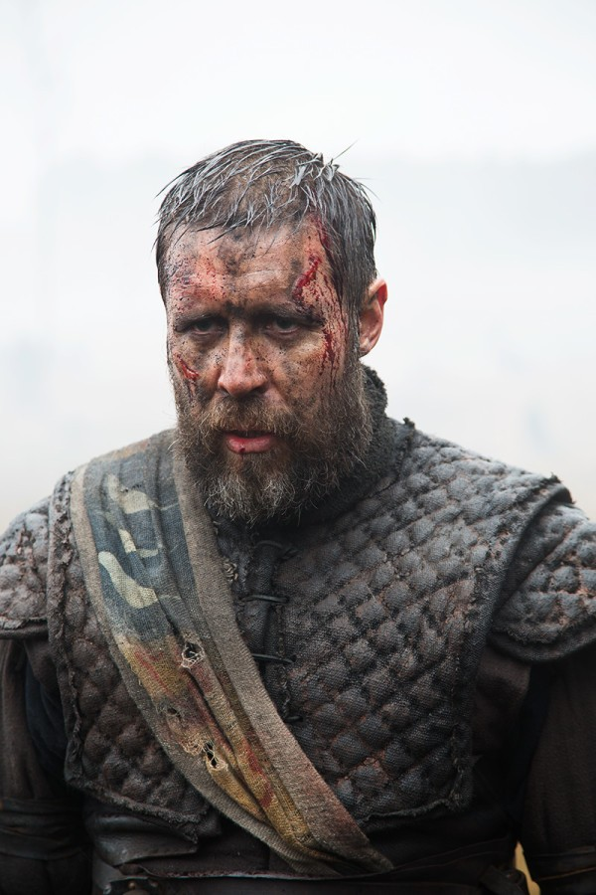 | Chosen quotations:  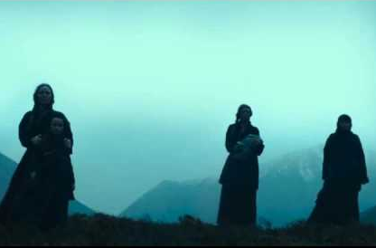
Summarise Macbeth’s response | Summarise Banquo’s response | Summarise Banquo’s thoughts on Macbeth

Pen to paper
Shakespeare has used a number of linguistic and structural techniques to mark the first meeting of Macbeth and the witches. Can you mix and match the techniques with their example?
Contradictions
Alliteration
‘You should be women, / And yet your beards forbid me to interpret that you are so.’
Adjectives
‘Would they had stayed!’

Imperative sentence
Interrogative sentence
‘Stay, you imperfect speakers, tell me more’
Nouns

‘What are these so wild and withered in their attire’
Exclamatory sentence
‘Say from whence you owe this strange intelligence?’

‘Lesser than Macbeth and greater / Not so happy, yet much happier.’
‘Or have we eaten on the insane root / That takes the reason prisoner?’

Reflection
Reflecting upon the task above, can you finish the sentence starts below
- Interrogative sentences reveal Macbeth’s
_________________________________________________________________________________________________________________________________________________________________________________________________________
- Gender subversion occurs through
_________________________________________________________________________________________________________________________________________________________________________________________________________
- Imperative sentences are used because
_________________________________________________________________________________________________________________________________________________________________________________________________________
- Banquo’s feelings are clearly expressed through the use of adjectives
_________________________________________________________________________________________________________________________________________________________________________________________________________
- Macbeth is impatient and this is revealed through Shakespeare’s use of
_________________________________________________________________________________________________________________________________________________________________________________________________________

Learning episode 9
Do it now task
Recap questions:
- What was a commonly-held belief about life during Shakespeare’s time?
_________________________________________________________________________________________________________________________________________________________________________________________________________
- Who is said to have control over the characters’ destinies in Macbeth?
___________________________________________________________________
- What is metonymy?
______________________________________________________________________________________________________________________________________
- What line does Macbeth mirror and why do you think Shakespeare has Macbeth do this?
______________________________________________________________________________________________________________________________________
- Identify three ways in which Macbeth and Banquo describe the witches.
_________________________________________________________________________________________________________________________________________________________________________________________________________
- What three things do the witches predict for Macbeth?
_________________________________________________________________________________________________________________________________________________________________________________________________________
- What do they tell Banquo?
______________________________________________________________________________________________________________________________________
- How can you tell the witches have caught Macbeth’s attention?
_________________________________________________________________________________________________________________________________________________________________________________________________________
- What is the difference between an interrogative, imperative and exclamatory sentence?
_________________________________________________________________________________________________________________________________________________________________________________________________________

New knowledge
In fiction, a foil is a character who contrasts with another character – usually the protagonist – in order to highlight particular qualities of the other character. The word foil comes from the old practice of backing gems with foil in order to make them shine more brightly.
Pen to paper
Look at the famous pairings below: which character is the protagonist and which character is the foil? What makes them a foil?
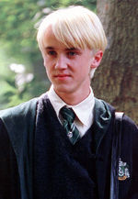
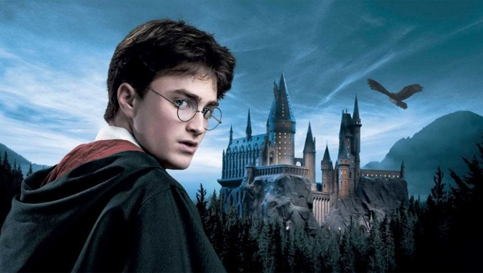
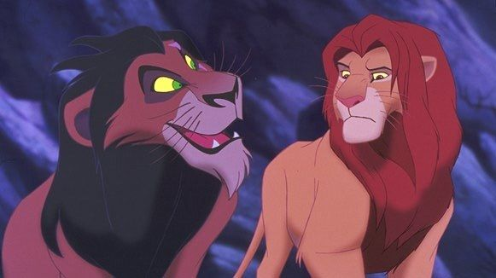

What evidence do we have to suggest that Banquo might be Macbeth’s foil?
_______________________________________________________________________________________________________________________________________________________________________________________________________________________________________________________________________________________________________________________________________________
New knowledge
Key task: Read the extract from Act One Scene Three
 | ROSS
91 | The king hath happily received, Macbeth,
92 | the news of thy success, and when he reads
93 | thy personal venture in the rebels’ fight,
94 | his wonders and praise do contend
95 | which should be thine or his. Silenced with that,
96 | in viewing o’er the rest o’ the selfsame day,
97 | he finds thee in the stout Norweyan ranks,
98 | nothing afeard of what thyself didst make,
99 | strange images of death. As thick as tale
100 | can post with post, and every one did bear
101 | thy praises in his kingdom’s great defense,
102 | and poured them down before him.
 | ANGUS
103 | We are sent
104 | to give thee from our royal master thanks,
105 | only to herald thee into his sight,
106 | not pay thee.
 | ROSS
107 | And, for an earnest of a greater honour,
108 | he bade me, from him, call thee thane of Cawdor:
109 | in which addition, hail, most worthy thane,
110 | for it is thine.
 | BANQUO
111 | What, can the devil speak true?
 | MACBETH
112 | The thane of Cawdor lives. Why do you dress me
113 | in borrowed robes?
 | ANGUS
114 | Who was the thane lives yet,
115 | but under heavy judgement bears that life
116 | which he deserves to lose. Whether he was combined
117 | with those of Norway, or did line the rebel
118 | with hidden help and vantage, or that with both
119 | he laboured in his country’s wrack, I know not;
120 | but treasons capital, confessed and proved,
121 | have overthrown him.
 | MACBETH
122 | (aside) Glamis, and thane of Cawdor!
123 | The greatest is behind. (to ROSS and ANGUS) Thanks for
124 | your pains.
125 | (aside to BANQUO) Do you not hope your children shall be
126 | kings,
127 | when those that gave the thane of Cawdor to me
128 | promised no less to them?
 | BANQUO
129 | That, trusted home,
130 | might yet enkindle you unto the crown,
131 | besides the thane of Cawdor. But ‘tis strange.
132 | And oftentimes, to win us to our harm,
133 | the instruments of darkness tell us truths,
134 | win us with honest trifles, to betray’s
135 | in deepest consequence.
136 | (to ROSS and ANGUS) Cousins, a word, I pray you.
 | BANQUO, ROSS and ANGUS move to one side.

Pen to paper
- What news does Ross bring to Macbeth and Banquo?
______________________________________________________________________________________________________________________________________

- How do Macbeth and Banquo react to the news from Ross? Pick out quotations that show Macbeth’s reaction and write these on the left and quotations that show Banquo’s reaction and write these on the right.

- What can you infer about Macbeth and Banquo’s attitude to the witches’ prophecies from these reactions?
_______________________________________________________________________________________________________________________________________________________________________________________________________________________________________________________________________________________________________________________________________________
Pen to paper
Let’s focus in on the character of Banquo here by exploding a key quotation:

The instruments of darkness tell us truths,
Win us with honest trifles, to betray’s
In deepest consequence

Questions for consideration:
- What inferences can we make about Banquo’s attitude towards the witches?
- Which words are key? What type of words are these? Noun? Verb? Adjective? Adverb?
- What do these words suggest about Banquo’s thoughts? How can we interpret these words?
- How does this quotation reinforce that Banquo is Macbeth’s foil?

Reflection
‘Shakespeare has crafted Banquo to be Macbeth’s foil.’
Copy the following question into your formative assessment book and then use the grid below to respond to the question.
How does the quotation ‘the instruments of darkness tell us truths, / Win us with honest trifles, to betray’s / In deepest consequence’ reinforce this notion?

 | Topic sentence | What point are you making about the relationship between Macbeth and Banquo?
 | Example | Which line are you using as your evidence?  This is evident in the line…
 | Explanation | What does this line tell you about how Macbeth is viewed? (Remember: dictionary definition explanation)  This line tells me…
 | Exploration | Focus in on the language that has been used here. Which words are key? What do they reveal about Banquo’s thoughts? Is he Macbeth’s foil? Why?  The use of ____ suggests…
 | Effect | What would an audience think as a result? Which character would they prefer (Macbeth or Banquo) and why?  An audience would…

Learning episode 10
Do it now task
Recap questions:
- What is a foil?
______________________________________________________________________________________________________________________________________
- What evidence is there to suggest Banquo is a foil in the lead up to this scene?
_________________________________________________________________________________________________________________________________________________________________________________________________________
- What news does Ross bring Macbeth and Banquo?
______________________________________________________________________________________________________________________________________
- How does Macbeth react?
_________________________________________________________________________________________________________________________________________________________________________________________________________
- Identify a method Shakespeare has used to convey Macbeth’s reaction.
______________________________________________________________________________________________________________________________________
- What does Banquo say to Macbeth?
_________________________________________________________________________________________________________________________________________________________________________________________________________
- Identify a method Shakespeare has used to convey Banquo’s reaction.
______________________________________________________________________________________________________________________________________
New knowledge
Read the following information on The Great Chain of Being and the divine right of kings.
AO3
Context
1 | Elizabethans believed that God set out an order for everything
2 | in the universe. This was known as the Great Chain of Being.
3 | On Earth, God created a social order for everybody and chose
4 | where you belonged. In other words, the king or queen was
5 | in charge because God put them there and they were only
6 | answerable to God (the Divine Right of Kings). This meant
7 | that disobeying the monarch was a sin, which was handy
8 | for keeping people in their place! Love and obey your
9 | monarch and you would go to heaven. Defy or betray your
10 | monarch (TREASON) or kill a king (REGICIDE) and you
11 | were killing a God, and you would surely go to Hell. You
12 | would be branded a traitor. In Dante’s Inferno, the lowest
13 | circle of hell was reserved for traitors. If you were caught
14 | your execution would see you hanged, drawn and quartered.
15 | This consisted of hanging till almost dead, then your insides
16 | pulled out and your body cut into four pieces. Unless you
17 | were a woman, in which case you’d be burnt at the stake. It
18 | also led to the idea that if the wrong person was monarch
19 | everything would go wrong for a country, including whether
20 | the crops would be good, or if animals behaved as they
21 | should.
22 | James I was a firm believer in The Divine Right of Kings and
23 | in 1599 he wrote the Basilikon Doron, a treatise on
24 | government, which sets out the Christian justification for a
25 | monarch’s absolute power. He was also the patron saint of
26 | Shakespeare’s company so Shakespeare would present any
27 | act of regicide as an act of extreme evil.
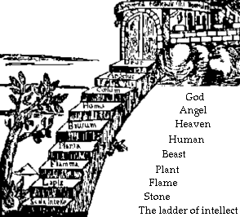

New knowledge
Let’s read the end of Act One Scene 3 in which Macbeth considers what Ross has told him.
 | MACBETH
1 | (Aside) Two truths are told,
2 | As happy prologues to the swelling act
3 | Of the imperial theme – I thank you, gentlemen.
4 | This supernatural soliciting,
5 | Cannot be ill, cannot be good: if ill,
6 | Why hath it given me earnest of success,
7 | Commencing in a truth? I am Thane of Cawdor:
8 | If good, why do I yield to that suggestion
9 | Whose horrid image doth unfix my hair
10 | And make my seated heart knock at my ribs,
11 | Against the use of nature? Present fears
12 | Are less than horrible imaginings:
13 | My thought, whose murder yet is but fantastical,
14 | Shakes so my single state of man that function
15 | Is smothered in surmise, and nothing is
16 | But what is not.
 | BANQUO
17 | Look, how our partner’s rapt.
 | MACBETH
18 | (Aside) If chance will have me king, why, chance may crown
19 | me,
20 | Without my stir.
 | BANQUO
21 | New honours come upon him.
22 | Like our strange garments, cleave not to their mould
23 | But with the aid of use.
 | MACBETH
24 | (Aside) Come what come may,
25 | Time and the hour runs through the roughest day.
 | BANQUO
26 | Worthy Macbeth, we stay upon your leisure.
 | MACBETH
27 | Give me your favour: my dull brain was wrought
28 | With things forgotten. Kind gentleman, your pains
29 | Are register’d where every day I turn
30 | The leaf to read them. Let us toward the king.
31 | (To Banquo) Think upon what hath chanced, and, at more
32 | time.
33 | The interim having weigh’d it, let us speak
34 | Our free hearts each to other.
 | BANQUO
35 | Very gladly.
 | MACBETH
36 | Till then, enough. Come, friends.

Pen to paper
Key task: Look at the utterances spoken by Macbeth below. Decide whether he has spoken these utterances aloud to other characters or whether these are Macbeth’s secret thoughts, spoken only to the audience. If spoken to other characters, put a speech bubble around them. If spoken to other characters, put a thought bubble around them.

I’m already Glamis, not I’m Thane of Cawdor. I’m well on the way to becoming King! |  | Thank you for the trouble you’ve gone to bring me this news.
 | I’ve already got a horrid picture in my mind of what I’m being tempted to do… |  | Is this news good or evil? Where do the witches get their knowledge from?
Surely I can’t be Thane of Cawdor! He’s alive and well. You’ve made a mistake. |  | Banquo, I want to talk with you later about what has happened to us today after we’ve both had a chance to think about it.

Key question: what do you notice? Why do you think this is?
_______________________________________________________________________________________________________________________________________________________________________________________________________________________________________________________________________________________________________________________________________________

Key task: Look more closely at the words spoken by Macbeth. Can you find the evidence to support the following statements?
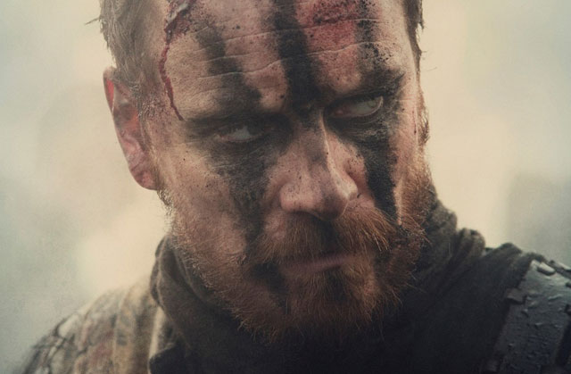 | This news from Ross is agreeable…
 | This news from Ross is testing…
Key question: If we track Banquo, what do the following quotations reveal about how Banquo observes Macbeth upon receiving this news?
Look how our partner’s rapt | New honours come upon him / Like our strange garments, cleave not to their mould / But with the aid of use.

Key question: The scene ends with Macbeth saying ‘Come what come may, Time and hour runs through the roughest day.’ What is Macbeth saying here? What structural technique is used and why?
_______________________________________________________________________________________________________________________________________________________________________________________________________________________________________________________________________________________________________________________________________________
Reflection
To summarise your learning from today’s lesson, copy the following question into your formative assessment book and respond using the key words below in your response.
What effect does the news from Ross have on Macbeth and Banquo?
Try to include as many of the following words in your response:
ambitious | wavered | The Great Chain of Being | repelled
pensive | suspicious | regicide | apprehension

Offer your opinion about how the characters react to the news from Ross

Support your opinion with a textual reference and a brief link to the wider social and historical context of regicide during this time.

Try to make 3 points about how Macbeth and Banquo respond and aim to use shorter textual references. Link Macbeth and Banquo’s response to Ross to the wider social and historical context of The Great Chain of Being and the act of committing regicide.

Learning episode 11
Do it now task
Recap questions:
- What is the Great Chain of Being?
____________________________________________________________________________________________________________________________________________________________________________________________________________________________________________________________________________
- What does the word ‘regicide’ mean?
___________________________________________________________________
- What would happen if you went against God?
_________________________________________________________________________________________________________________________________________________________________________________________________________
- What was James I’s view on the Divine Right of Kings?
_________________________________________________________________________________________________________________________________________________________________________________________________________
- Ross has informed Macbeth that the king has made him Thane of Cawdor, how does Macbeth respond?
____________________________________________________________________________________________________________________________________________________________________________________________________________________________________________________________________________
- In what ways is Banquo’s reaction different?
____________________________________________________________________________________________________________________________________________________________________________________________________________________________________________________________________________
- What does Banquo notice about Macbeth’s change in character?
_________________________________________________________________________________________________________________________________________________________________________________________________________
- Why is Banquo Macbeth’s foil?
_________________________________________________________________________________________________________________________________________________________________________________________________________
New knowledge
AO3
Context
1 | Macbeth as a text holds true to the historical facts of the
2 | monarchy in Scotland. Scotland was both an elective monarchy
3 | and a tanistry. An elective monarchy is a monarchy ruled by an
4 | elective monarch, in contrast to a hereditary monarchy in which
5 | the office is automatically passed down as a family inheritance.
6 | The group of nobleman, who could be selected as monarch,
7 | would have been small. Tanistry was a Gaelic system for
8 | passing on titles and lands. In this system the Tanist would be
9 | chosen from a pool to succeed to a title. You could also be
10 | named as Tanist by attaining a high rank. Thus Macbeth holds
11 | some claim to now being inline to succeed to the throne.

Pen to paper
Look at the short extract below taken from the scene that we are going to explore today and answer the questions that follow.

 | DUNCAN
39 | My plenteous joys,
40 | Wanton in fullness, seek to hide themselves
41 | In drops of sorrow. Sons, kinsmen, thanes,
42 | And you whose places are the nearest, know
43 | We will establish our estate upon
44 | Our eldest, Malcolm, whom we name hereafter
45 | The Prince of Cumberland; which honour must
46 | Not unaccompanied invest him only,
47 | But signs of nobleness, like stars, shall shine
48 | On all deservers. From hence to Inverness,
49 | And bind us further to you.

- Who is next in line to be king?
___________________________________________________________________
- Does this make the monarchy elective or hereditary?
___________________________________________________________________
- Why is Macbeth in line for the throne too?
______________________________________________________________________________________________________________________________________
New knowledge
Let’s read Act One Scene Four in which Macbeth learns that Duncan’s son, Malcolm is next in line for the throne.
 | Flourish. Enter DUNCAN, MALCOLM, DONALBAIN, LENNOX and Attendants.
 | DUNCAN
1 | Is execution done on Cawdor? Are not
2 | Those in commission yet return’d?
 | MALCOLM
3 | My liege,
4 | They are not yet come back. But I have spoke
5 | With one that saw him die: who did report
6 | That very frankly he confess’d his treasons,
7 | Implored your highness’ pardon and set forth
8 | A deep repentance: nothing in his life
9 | Became him like the leaving it; he died
10 | As one that had been studied in his death
11 | To throw away the dearest thing he owed,
12 | As ‘twere a careless trifle.
 | DUNCAN
13 | There’s not art
14 | To find the mind’s construction in the face:
15 | He was a gentleman on whom I built
16 | An absolute trust.
 | Enter MACBETH, BANQUO, ROSS and ANGUS
17 | O worthiest cousin!
18 | The sin of my ingratitude even now
19 | Was heavy on me: thou art so far before
20 | That swiftest wing of recompense is slow
21 | To overtake thee. Would thou hadst less deserved,
22 | That the proportion both of thanks and payment
23 | Might have been mine! Only I have left to say,
24 | More is thy due than more than all can pay.
 | MACBETH
25 | The service and the loyalty I owe,
26 | In doing it, pays itself. Your highness’ part
27 | Is to receive our duties; and our duties
28 | Are to your throne and state children and servants,
29 | Which do but what they should, by doing everything
30 | Safe toward your love and honour.
 | DUNCAN
31 | Welcome hither:
32 | I have begun to plant thee, and will labour
33 | To make thee full of growing. Noble Banquo,
34 | That hast no less deserved, nor must be known
35 | No less to have done so, let me enfold thee
36 | And hold thee to my heart.
 | BANQUO
37 | There if I grow,
38 | The harvest is your own.
 | DUNCAN
39 | My plenteous joys,
40 | Wanton in fullness, seek to hide themselves
41 | In drops of sorrow. Sons, kinsmen, thanes,
42 | And you whose places are the nearest, know
43 | We will establish our estate upon
44 | Our eldest, Malcolm, whom we name hereafter
45 | The Prince of Cumberland; which honour must
46 | Not unaccompanied invest him only,
47 | But signs of nobleness, like stars, shall shine
48 | On all deservers. From hence to Inverness,
49 | And bind us further to you.
 | MACBETH
50 | The rest is labour, which is not used for you:
51 | I’ll be myself the harbinger and make joyful
52 | The hearing of my wife with your approach;
53 | So humbly take my leave.
 | DUNCAN
54 | My worthy Cawdor!
 | MACBETH
55 | (Aside) The Prince of Cumberland! That is a step
56 | On which I must fall down, or else o’erleap
57 | For in my way it lies. Stars, hide your fires;
58 | Let not light see my black and deep desires:
59 | The eye wink at the hand; yet let that be,
60 | Which the eye fears, when it is done, to see.
 | Exit
 | DUNCAN
61 | True, worthy Banquo; he is full so valiant,
62 | And in his commendations I am fed;
63 | It is a banquet to me. Let’s after him,
64 | Whose care is gone before to bid us welcome:
65 | It is a peerless kinsman.
 | Flourish. Exeunt.

Pen to paper

Complete the following chart, making a note on the techniques and devices used in this scene and what is revealed as a result about the relationship between King Duncan and Macbeth and King Duncan and Banquo.
Technique | Quotation | Analysis
Foreshadowing  A literary device in which a writer gives an advance hint of what is to come later in the story | To throw away the dearest thing he owed, / As ‘twere a careless trifle. | Focus = relationship between King Duncan and Macbeth
Dramatic irony  A situation, or the irony arising from a situation, in which the audience has a fuller knowledge of what is happening in a drama than a character does | DUNCAN  There’s not art  To find the mind’s construction in the face:  He was a gentleman on whom I built  An absolute trust.  Enter MACBETH, BANQUO, ROSS and ANGUS  O worthiest cousin! | Focus = relationship between King Duncan and Macbeth
 | The service and the loyalty I owe, / In doing it, pays itself. | Focus = relationship between King Duncan and Macbeth
Anadiplosis  The rhetorical repetition of the last word or words of one phrase or sentence at the beginning of the next.  (and dramatic irony) | Your highness’ part / Is to receive our duties; and our duties / Are to your throne and state children and servants | Focus = relationship between King Duncan and Macbeth
Metaphor  A figure of speech which makes an implicit, implied or hidden comparison between two things. | Macbeth: I have begun to plant thee, and will labour / To make thee full of growing.  Banquo: There If I grow, / The harvest is your own. | Focus = relationship between King Duncan and Banquo
Aside  A remark or passage in a play that is intended to be heard by the audience but is supposed to be unheard by the other characters in the play. | The Prince of Cumberland! That is a step / On which I must fall down, or else o’erleap / For in my way it lies. | Focus = relationship between King Duncan and Macbeth
Imagery  Figurative language used to represent objects, actions and ideas in such a way that it appeals to our physical senses. | Stars, hide your fires; / Let not light see my black and deep desires | Focus = relationship between King Duncan and Macbeth

Reflection
Copy the following question into your formative assessment book and use the grid below to help you respond to the question.
What methods does Shakespeare use in Act 1 Scene 4 to present the relationship between King Duncan and Macbeth or King Duncan and Banquo?

 | Technique | What technique has been used to present the relationship between King Duncan and Macbeth or King Duncan and Banquo?
 | Example | Which line are you using as your evidence?  This is evident in the line…
 | Explanation | What does this line tell you about the relationship between these characters? (Remember: dictionary definition explanation)  This line tells me…
 | Exploration | Focus in on the technique that has been used here. How does the use of this technique affect what we learn about the relationship between characters?  The use of ____ suggests…
 | Effect | What would an audience think as a result?  An audience would…
Learning episode 12
Do it now task
Recap questions:
- What is the difference between an elective monarchy and a hereditary monarchy?
______________________________________________________________________________________________________________________________________
- Who does King Duncan name as his successor and why is this significant?
_________________________________________________________________________________________________________________________________________________________________________________________________________
- Why is that Macbeth is also in line for the throne?
______________________________________________________________________________________________________________________________________
- What is foreshadowing?
______________________________________________________________________________________________________________________________________
- What is dramatic irony?
______________________________________________________________________________________________________________________________________
- What is anadiplosis?
______________________________________________________________________________________________________________________________________
- What is a metaphor?
______________________________________________________________________________________________________________________________________
- What is an aside?
______________________________________________________________________________________________________________________________________
- What is imagery?
______________________________________________________________________________________________________________________________________
- Identify three adjectives to describe the relationship between King Duncan and Macbeth and explain the choices you make.
____________________________________________________________________________________________________________________________________________________________________________________________________________________________________________________________________________
- How would you describe the relationship between King Duncan and Banquo?
______________________________________________________________________________________________________________________________________

New knowledge
In today’s lesson, we are going to be introduced to the character of Lady Macbeth. Before we read Act 1 Scene 5, read the contextual information below about women during the Jacobean era. This information is taken from http://elizabethi.org/contents/women/
AO3
Context
 | Patriarchal Society
1 | Jacobean society was patriarchal, meaning that men were
2 | considered to be the leaders and women their inferiors. Women
3 | were regarded as “the weaker sex”, not just in terms of physical
4 | strength, but emotionally too. It was believed that women always
5 | needed someone to look after them. If they were married, their
6 | husband was expected to look after them. If they were single,
7 | then their father, brother or another male relative was expected
8 | to take care of them.
 | Housewives and mothers
9 | Even though there had been an unmarried woman on the throne
10 | In Elizabethan England, the roles of women in society were very
11 | limited. There were very clear expectations of men and women,
12 | and in general men were expected to be the breadwinners and
13 | women to be housewives and mothers. On average, a woman
14 | gave birth to a child every two years, but as a lot of babies and
15 | children died from sickness, families were not always large.
16 | Childbearing was considered a great honour to women, as
17 | children were seen as blessings from God.
 | Professional women
18 | Women were not allowed to enter the professions i.e. law,
19 | medicine, politics, but they could work in domestic service as
20 | cooks, maids, etc. Women were also allowed to write works of
21 | literature, providing the subject was suitable for women: mainly
22 | translations or religious works. Women were not allowed to act
23 | on the public stage or write for the public stage. Acting was
24 | considered dishonourable for women. In Shakespeare’s plays,
25 | the roles of women were often played by young boys.
 | Marriage
26 | A man was considered to be the head of a marriage, and he had
27 | the legal right to chastise his wife. However, it is important to
28 | understand what this “headship” meant. It did not mean, as if
29 | often supposed, that the husband was able to command his wife
30 | to do anything he pleased. He was expected to take care of her,
31 | make sure she had everything she needed, and most importantly
32 | to love her and be a good father to any children they had. If a
33 | husband felt the need to chastise his wife, then he was not
34 | allowed to be cruel or inflict bodily harm. If he did abuse his wife,
35 | then he could be prosecuted or prevented from living with her.
36 | There was no divorce: marriage generally lasted as long as the
37 | couple both lived.

Pen to paper
From your prior learning, to what extent would you describe Lady Macbeth as a typical Jacobean woman?
________________________________________________________________________________________________________________________________________________________________________________________________________________________________________________________________________________________________________________________________________________________________________________________________________________________________________________________________________________________________________________________________________________________

New knowledge
In today’s lesson, we are going to read Act One Scene Five. In this scene, we meet Lady Macbeth who receives news from Macbeth about recent events.

Shakespeare uses a soliloquy to present Lady Macbeth’s response to Macbeth’s news. A soliloquy is a literary device used in drama in which the innermost thoughts of a character are voiced to him/herself.

Extract Seven: Act One Scene 5 (Lady Macbeth)
 | Enter LADY MACBETH, reading a letter
 | LADY MACBETH
1 | They met me in the day of success: and I have
2 | Learned by the perfectest report, they have more in
3 | Them than mortal knowledge. When I burned in desire
4 | To question them further, they made themselves air,
5 | Into which they vanished. Whiles I stood rapt in
6 | The wonder of it, came missives from the king, who
7 | All-hailed me Thane of Cawdor, by which title,
8 | Before, these weird sisters saluted me, and referred
9 | Me to the coming on of time, with ‘Hail, king that
10 | Shalt be!’ This have I thought good to deliver
11 | Thee, my dearest partner of greatness, that thou
12 | Mightiest not lose the dues of rejoicing, by being
13 | Ignorant of what greatness is promised thee. Lay it
14 | To thy heart, and farewell.
15 | Glamis thou art, and Cawdor; and shalt be
16 | What thou art promised: yet do I fear thy nature;
17 | It is too full o’ the milk of human kindness
18 | To catch the nearest way: thou wouldst be great;
19 | Art not without ambition, but without
20 | The illness should attend it: what thou wouldst highly,
21 | That wouldst thou holily; wouldst not play false,
22 | And yet wouldst wrongly win: thou’ldst have, great Glamis,
23 | That which cries ‘Thus thou must do, if thou have it;
24 | And that which rather thou dost fear to do
25 | Than wishes should be undone.’ Hie thee hither,
26 | That I may pour my spirits in thine ear;
27 | And chastise with the valour of my tongue
28 | All that impedes thee from the golden round,
29 | Which fate and metaphysical and doth seem
30 | To have thee crown’d withal.

Pen to paper
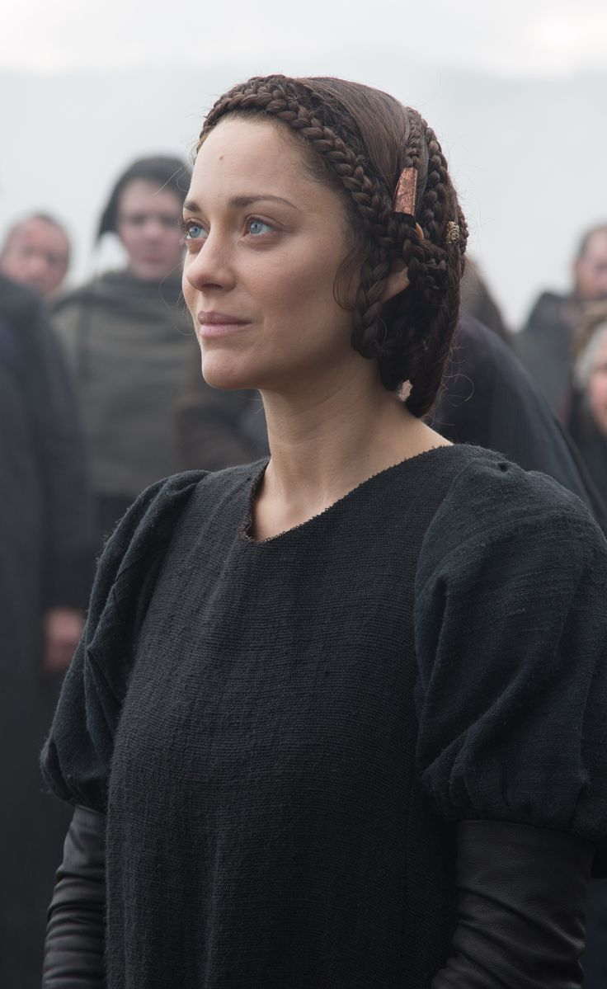
Look at lines 15-30 and Lady Macbeth’s immediate response to Macbeth’s letter.

What does Lady Macbeth believe is Macbeth’s critical weakness?

What does Lady Macbeth believe must happen?

What are her plans?
New knowledge

 | Enter a Messenger
31 | What is your tidings?
 | Messenger
32 | The king comes here to-night.
 | LADY MACBETH
33 | Thou’rt made to say it:
34 | Is not thy master with him? Who, were’t so,
35 | Would have inform’d for preparation.
 | Messenger
36 | So please you, it is true: our thane is coming:
37 | One of my fellows had the speed of him,
38 | Who, almost dead for breath, had scarcely more
39 | Than would make up his message.
 | LADY MACBETH
40 | Give him tending;
41 | He brings great news.
 | Exit Messenger
42 | The raven himself is hoarse
43 | That croaks the fatal entrance of Duncan
44 | Under my battlements. Come, you spirits
45 | That tend on mortal thoughts, unsex me here,
46 | And fill me from the crown to the toe top-full
47 | Of direst cruelty! Make thick me blood;
48 | Stop up the access and passage to remorse,
49 | That no compunctious visitings of nature
50 | Shake my fell purpose, nor keep peace between
51 | The effect and it! Come to my woman’s breasts,
52 | And take my milk for gall, you murdering ministers,
53 | Wherever in your sightless substances
54 | You wait on nature’s mischief! Come, thick night,
55 | And pall thee in the dunnest smoke of hell,
56 | That my keen knife sees not the wound it makes,
57 | Nor heaven peep through the blanket of the dark,
58 | To cry ‘Hold, hold!’

Pen to paper
Lady Macbeth is not a typical Jacobean woman. Right from the outset, she appears ambitious and is determined the king should die. In addition, believing Macbeth to be too kind, she aims to take control of the situation.
The raven himself is hoarse / That croaks the fatal entrance of Duncan / Under my battlements  The raven is an ill omen and a symbol of impending death. What does this imply about Lady Macbeth’s immediate thoughts? | Come, you spirits / That tend on mortal thoughts  Who is Lady Macbeth calling? What associations can we make here? |  | Unsex me here  What is Lady Macbeth asking?
Fill me from the crown to the toe top-full of direct cruelty!  What is suggested about Lady Macbeth’s character here? | 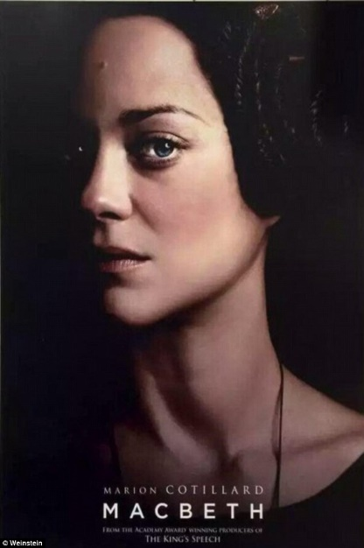 |  | Stop up the access and passage to remorse.  How does this quotation reveal her determination?
Come to my woman’s breasts, / And take my milk for gall.  Gall is a poison. Why does this quotation reveal Lady Macbeth to be evil and cruel? |  | Come, thick night / And pall thee in the dunnest smoke of hell, / That my keen knife sees not the wound it makes, / Nor heaven peep through the blanket of the dark  How does this connect with Macbeth’s utterances earlier?

Reflection
Key question: Why is Lady Macbeth more dangerous than the witches?
_______________________________________________________________________________________________________________________________________________________________________________________________________________________________________________________________________________________________________________________________________________

Learning episode 13
Do it now task
Recap questions:
- What does the word ‘patriarchal’ mean?
______________________________________________________________________________________________________________________________________
- What were the expectations of women during this time?
_________________________________________________________________________________________________________________________________________________________________________________________________________
- What is a soliloquy?
______________________________________________________________________________________________________________________________________
- What is Lady Macbeth’s immediate response to Macbeth’s news?
______________________________________________________________________________________________________________________________________
- What does she fear about Macbeth?
______________________________________________________________________________________________________________________________________
- What does a raven symbolise?
______________________________________________________________________________________________________________________________________
- What connection do we see between Lady Macbeth and the supernatural? Why do you think this is?
_________________________________________________________________________________________________________________________________________________________________________________________________________
- Why does Lady Macbeth say ‘Unsex me here’?
______________________________________________________________________________________________________________________________________
- How do we know Lady Macbeth is ambitious and determined?
____________________________________________________________________________________________________________________________________________________________________________________________________________________________________________________________________________
- How has imagery of light and dark been used?
_________________________________________________________________________________________________________________________________________________________________________________________________________
New knowledge
Read through the following contextual information.
AO3
Context
 | Eve and the Serpent
1 | God took some clay from the ground and made the shape of
2 | a man. Then He breathed gently into the shape. The man’s
3 | eye’s opened and he began to live. God called him Adam.
4 | The Lord made a beautiful garden for him to live in. The
5 | garden, called Eden, was full of many wonderful things.
6 | beautiful flowers grew everywhere. Birds sang in the trees,
7 | streams flowed through the valley and animals roamed
8 | across the fields.. God brought all the animals to Adam one
9 | at a time to be given their names. “Elephant,” he would say,
10 | or “Tiger”, or “Porcupine.”
11 | God had made the man in His image to keep Him company
12 | and look after the world. But God felt sorry for Adam. “None
13 | of the animals is really like him,” thought God, “he needs
14 | someone to share his life. Someone who cares for him
15 | and who he can care for.”
16 | That night, God took a rib from Adam’s side and made a
17 | woman. When Adam awoke the following morning, he found
18 | a wife, Eve, lying asleep beside him. Adam was so happy.
19 | He took her hand and she woke up. She looked up at him
20 | and smiled.
21 | God told the man and woman that it was their job to take
22 | care of their new home. God blessed them, saying “All
23 | this is for you. Help yourself to anything you like. But
24 | never touch the tree in the middle of the Garden. That
25 | tree gives knowledge of good and evil. The day you eat
26 | its fruit, you will die.”
27 | God did not mean that Adam and Eve would drop down dead
28 | the moment they ate the fruit from the tree. He meant that
29 | in time they would die without His Spirit dwelling in them.
30 | One day, Adam and Eve were gathering berries for dinner
31 | when she head a silly voice behind her. “Has God told you
32 | that you can eat the fruit from all the trees?” the voice
33 | asked softly. Eve turned around to see a snake talking to her.
34 | “God has told us we can eat all the fruit except for what grows
35 | On The Tree of the Knowledge of Good and Evil,” Eve told
36 | the serpent.
37 | “Oh come now, that’s silly! I hardly think such a lovely fruit
38 | would do you any harm,” the serpent lied. “God knows
39 | that if you eat from The Tree of the Knowledge of Good and
40 | Evil you’ll become just like God, and will be able to decide for
41 | yourself what is right and what is wrong.”
42 | The woman looked at the fruit and thought how tasty it looked.
43 | she thought how wonderful it would to be as wise and
44 | powerful as God. She believed the serpent’s lie and ate the
45 | fruit and also gave some to Adam, who was with her, and he
46 | took a bit as well.
47 | She felt a strange feeling in the pit of her stomach. She
48 | fidgeted and wondered what was wrong with her. Suddenly
49 | she realised that she was feeling guilty – she had disobeyed
50 | God and knew she’d done something wrong.
51 | As soon as they ate the fruit a change came over Adam and
52 | Eve. They became unhappy and fearful of God.
53 | Adam and Eve heard God calling them. Without thinking,
54 | They dived into the bushes, but God knew where they were.
55 | when God asked them if they had eaten from The Tree of the
56 | Knowledge of Good and Evil that He had told them not to
57 | touch, they blamed each other for their sins.
58 | God was sad that Adam and Eve had disobeyed them. He
59 | told them that they had to leave the Garden of Eve, “From
60 | now on you’ll have to scratch a living from the soil. You’ll
61 | need to make clothes and grow food. Nothing will come
62 | easily – not even childbirth. And one day, you will die.”

Pen to paper
Summarise the story of Eve and the Serpent in 50 words or fewer.
_______________________________________________________________________________________________________________________________________________________________________________________________________________________________________________________________________________________________________________________________________________
New knowledge
Let’s read Act One Scene 5 where Lady Macbeth and Macbeth meet for the first time since the battle and discuss their thoughts with the regard to King Duncan.
 | Enter MACBETH
1 | Great Glamis! Worthy Cawdor!
2 | Greater than both, by the all-hail hereafter!
3 | Thy letters have transported me beyond
4 | This ignorant present, and I feel now
5 | The future in the instant.
 | MACBETH
6 | My dearest love,
7 | Duncan comes here to-night.
 | LADY MACBETH
8 | And when goes hence?
 | MACBETH
9 | To-morrow, as he purposes.
 | LADY MACBETH
10 | O, never
11 | Shall sun that morrow see!
12 | Your face, my thane, is as a book where men
13 | May read strange matters. To beguile the time,
14 | Look like the time; bear welcome in your eye,
15 | Your hand, your tongue: look like the innocent flower,
16 | But be the serpent under’t. He that’s coming
17 | Must be provided for: and you shall put
18 | This night’s great business into my dispatch;
19 | Which shall to all our nights and days to come
20 | Give solely sovereign sway and masterdom.
 | MACBETH
21 | We will speak further.
 | LADY MACBETH
22 | Only look up clear;
23 | To alter favour ever is to fear:
24 | Leave all the rest to me.
 | Exeunt.

Pen to paper
- How does Macbeth address Lady Macbeth? How does Lady Macbeth address Macbeth? What does this reveal about their state of mind at this point and their relationship?
____________________________________________________________________________________________________________________________________________________________________________________________________________________________________________________________________________
- What type of sentence is used in lines 10/11 and why has this type of sentence been used?
____________________________________________________________________________________________________________________________________________________________________________________________________________________________________________________________________________
- What does Lady Macbeth tell Macbeth to do in lines 12-13?
______________________________________________________________________________________________________________________________________
- What connections can you draw between the story of Eve and the serpent and Lady Macbeth and Macbeth?
__________________________________________________________________________________________________________________________________________________________________________________________________________________________________________________________________________________________________________________________________________________________________________________________________________________
- How is Lady Macbeth not acting like a typical Jacobean woman here?
____________________________________________________________________________________________________________________________________________________________________________________________________________________________________________________________________________
- Why do you think Macbeth says ‘We will speak further’? What possible things might he be thinking at this point?
____________________________________________________________________________________________________________________________________________________________________________________________________________________________________________________________________________

Reflection
The mortals in Macbeth are more dangerous than the witches. Discuss.
________________________________________________________________________________________________________________________________________________________________________________________________________________________________________________________________________________________________________________________________________________________________________________________________________________________________________________________________________________________________________________________________________________________
Read Act One Scene Six below, where Duncan arrives at the castle, and then answer the questions that follow.
 | Hautboys and torches. Enter DUNCAN, MALCOLM, DONALBAIN, BANQUO, LENNOX, MACDUFF, ROSS, ANGUS and Attendants
 | DUNCAN
1 | This castle hath a pleasant seat; the air
2 | Nimbly and sweetly recommends itself
3 | Unto our gentle senses.
 | BANQUO
4 | This guest of summer,
5 | The temple-haunting martlet, does approve,
6 | By his loved mansionry, that the heaven’s breath
7 | Smells wooingly here: no jutty, frieze,
8 | Buttress, nor coign of vantage, but this bird
9 | Hath made his pendent bed and procreant cradle:
10 | Where they most breed and haunt, I have observed,
11 | The air is delicate.
 | Enter LADY MACBETH
 | DUNCAN
12 | See, see, our honour’d hostess!
13 | The love that follows us sometimes is our trouble,
14 | Which still we thank as love. Herein I teach you
15 | How you shall bid God ‘ild us for your pains,
16 | And thank us for your trouble.
 | LADY MACBETH
17 | All our service
18 | In every point twice done and then done double
19 | Were poor and single business to contend
20 | Against those honours deep and broad wherewith
21 | Your majesty loads our house: for those of old,
22 | And the late dignities heap’d up to them,
23 | We rest your hermits.
 | DUNCAN
24 | Where’s the thane of Cawdor?
25 | We coursed him at the heels, and had a purpose
26 | To be his purveyor: but he rides well;
27 | And his great love, sharp as his spur, hath holp him
28 | To his home before us. Fair and noble hostess,
29 | We are your guest to-night.
 | LADY MACBETH
30 | Your servants ever
31 | Have theirs, themselves and what is theirs, in compt,
32 | To make their audit at your highness’ pleasure,
33 | Still to return your own.
 | DUNCAN
34 | Give me your hand;
35 | Conduct me to mine host: we love him highly,
36 | And shall continue our graces towards him.
37 | By your leave, hostess.
 | Exeunt

Pen to paper
- When Duncan says ‘This castle hath a pleasant seat’, why is this an example of dramatic irony?
_________________________________________________________________________________________________________________________________________________________________________________________________________
- Do you think Banquo believes what he says between lines 4 and 11?
_________________________________________________________________________________________________________________________________________________________________________________________________________
- When Duncan refers to Lady Macbeth as ‘our honoured hostess’, why is this an example of dramatic irony?
_________________________________________________________________________________________________________________________________________________________________________________________________________
- What feelings are conjured up towards Lady Macbeth when you read lines 17-23?
_________________________________________________________________________________________________________________________________________________________________________________________________________
- Why when Lady Macbeth says ‘Your servants ever’ is this an example of dramatic irony?
_________________________________________________________________________________________________________________________________________________________________________________________________________
- What feelings are conjured up when Duncan asks to be taken to Macbeth and tells Lady Macbeth that ‘we love him highly’?
_________________________________________________________________________________________________________________________________________________________________________________________________________

Learning episode 14
Do it now task
Recap questions:
- How does the story of Eve and the Serpent connect with Macbeth and Lady Macbeth?
____________________________________________________________________________________________________________________________________________________________________________________________________________________________________________________________________________
- What do we learn about the relationship between Macbeth and Lady Macbeth based on the way that they address each other?
____________________________________________________________________________________________________________________________________________________________________________________________________________________________________________________________________________
- What evidence is there to suggest that Lady Macbeth begins to take control of the situation? Why does she do this?
____________________________________________________________________________________________________________________________________________________________________________________________________________________________________________________________________________
- Why do you think Macbeth says ‘We will speak further’?
____________________________________________________________________________________________________________________________________________________________________________________________________________________________________________________________________________
- Identify one example of dramatic irony from Act 1 scene 6.
______________________________________________________________________________________________________________________________________
- Do we believe Banquo when he tells Duncan that when the birds settle it is the sign of a good place?
______________________________________________________________________________________________________________________________________

New knowledge
A tragic hero is the protagonist of a tragedy in drama. Aristotle once said that “A man doesn’t become a hero until he can see the root of his own downfall.” An Aristotelian tragic hero must possess specific characteristics, five of which are below:
AO3
Context
- A flaw or error of judgement (hamartia).
- A reversal of fortune (peripeteia) brought about because of the hero’s error in judgement.
- The discovery or recognition that the reversal was brought about by the hero’s own actions (anagnorisis)
- Excessive pride (hubris)
- The character’s fate must be greater than deserved.
Some other common characteristics of a tragic hero:
- Hero must suffer more than he deserves
- Hero must be doomed from the start, but bears no responsibility for possessing his flaw.
- Hero must be noble in nature, but imperfect so that the audience can see themselves in him.
- Hero must have discovered his fate by his own actions, not by things happening to him.
- Hero must understand his doom, as well as the fact that his fate was discovered by his own actions.
- Hero’s story should arouse fear and empathy.
- Hero must be physically or spiritually wounded by his experiences, often resulting in his death.
- The hero must be intelligent so he may learn from his mistakes.
- The hero must have a weakness, usually it is pride.
- He has to be faced with a very serious decision that he has to make.

Pen to paper
To what extent, can Macbeth be described as a tragic hero?
_____________________________________________________________________________________________________________________________________________________________________________________________________________________________________________________________________________________________________________________________________________________________________________________________________________________________________________________________________________________

New knowledge
Let’s read Act 1 Scene 7 in which Macbeth reflects upon the decision that lies in front of him.
 | Hautboys and torches. Enter a Sewer, and divers Servants with dishes and service, and pass over the stage. Then enter MACBETH
 | MACBETH
1 | If it were done when ‘tis done, then ‘twere well
2 | It were done quickly: if the assassination
3 | Could trammel up the consequence, and catch
4 | With his surcease success; that but this blow
5 | Might be the be-all and the end-all here,
6 | But here, upon this bank and shoal of time,
7 | We’ld jump the life to come. But in these cases
8 | We still have judgement here; that we but teach
9 | Bloody instructions, which, being taught, return
10 | To plague the inventor: this even-handed justice
11 | Commends the ingredients of our poison’d chalice
12 | To our own lips. He’s here in double trust;
13 | First, as I am his kinsman and his subject,
14 | Strong both against the deed; then, as his host,
15 | Who should against his murderer shut the door,
16 | Not bear the knife myself. Besides, this Duncan
17 | Hath borne his faculties so meek, hath been
18 | So clear in his great office, that his virtues
19 | Will plead like angels, trumpet-tongued, against
20 | The deep damnation of his taking-off,
21 | And pity, like a naked new-born babe,
22 | Striding the blast, or heaven’s cherubim, horsed
23 | Upon the sightless couriers of the air,
24 | Shall blow the horrid deed in every eye,
25 | That tears shall down the wind. I have no spur
26 | To prick the sides of my intent, but only
27 | Vaulting ambition, which o’erleaps itself
28 | And falls on the other.

Pen to paper
In this speech Macbeth is deciding whether or not he should proceed in killing the king. Key question: why is this such a big decision?
______________________________________________________________________________________________________________________________________
Key task: complete the chart on the next page, identifying the textual references in which Macbeth presents the reasons why he should kill the king and the textual references in which Macbeth presents the reasons why he should not kill the king.
Reasons to kill the king | Reasons not to kill the king

Support: the following ideas are expressed by Macbeth. Use these ideas to find the quotations and place those quotations in the grid above.
By committing a violent crime, we teach people to commit more violence which will return to haunt us / me. I am a role model. | The king has treated me well. | If it ends with the murder, and it can be done quickly, I may consider it.
The king trusts me. | Duncan is a good leader. | The murder will have consequences.
My ambition is the only reason to kill Duncan. | It would be devastating for people. | Killing Duncan would lead me into a life of evil.

Reflection
Macbeth’s realisation that the only reason to kill Duncan is his ‘vaulting ambition’ means he decides not to proceed with killing the king. To what extent does this decision reinforce the presentation of Macbeth as a tragic hero?
________________________________________________________________________________________________________________________________________________________________________________________________________________________________________________________________________________________________________________________________________________________________________________________________________________________________________________________________________________________________________________________________________________________

Learning episode 15
Do it now task
Recap questions:
- What is a tragic hero?
______________________________________________________________________________________________________________________________________
- Identify 5 characteristics of a tragic hero.
____________________________________________________________________________________________________________________________________________________________________________________________________________________________________________________________________________
- What is a soliloquy?
______________________________________________________________________________________________________________________________________
- Identify 3 reasons that Macbeth puts forward for not killing the king.
_________________________________________________________________________________________________________________________________________________________________________________________________________
- What is the one argument Macbeth has for killing the king?
______________________________________________________________________________________________________________________________________
- To what degree do you think Macbeth is a tragic hero?
_________________________________________________________________________________________________________________________________________________________________________________________________________
New knowledge
Let’s read Act 1 Scene 7. In this scene, Macbeth tells Lady Macbeth that he does not want to ‘proceed’ any further in this business. Full of fury, Lady Macbeth attempts to persuade Macbeth to go ahead.
 | Enter LADY MACBETH
1 | How now! What news?
 | LADY MACBETH
2 | He has almost supp’d: why have you left the chamber?
 | MACBETH
3 | Hath he ask’d for me?
 | LADY MACBETH
4 | Know you not he has?
 | MACBETH
5 | We will proceed no further in this business:
6 | He hath honour’d me of late; and I have brought
7 | Golden opinions from all sorts of people,
8 | Which would be worn now in their newest gloss,
9 | Not cast aside so soon.
 | LADY MACBETH
10 | Was the hope drunk
11 | Wherein you dress’d yourself? Hath it slept since?
12 | And wakes it now, to look so green and pale
13 | At what it did so freely? From this time
14 | Such I account thy love. Art thou afeard
15 | To be the same in thine own act and valour
16 | As thou art in desire? Wouldst thou have that
17 | Which thou esteem’st the ornament of life,
18 | And live a coward in thine own esteem,
19 | Letting ‘I dare not’ wait upon ‘I would,’
20 | Like the poor cat I’ the adage?
 | MACBETH
21 | Prithee, peace:
22 | I dare do all that may become a man;
23 | Who dares do more is none.
 | LADY MACBETH
24 | What beast was’t, then,
25 | That made you break this enterprise to me?
26 | When you durst do it, then you were a man;
27 | And, to be more than what you were, you would
28 | Be so much more the man. Nor time nor place
29 | Did then adhere, and yet you would make both:
30 | They have made themselves, and that their fitness now
31 | Does unmake you. I have given suck, and know
32 | How tender ‘tis to love the babe that milks me:
33 | I would, while it was smiling in my face,
34 | Have pluck’d my nipple from his boneless gums,
35 | And dash’d the brains out, had I so sworn as you
36 | Have done to this.
 | MACBETH
37 | If we should fail?
 | LADY MACBETH
38 | We fail!
39 | But screw your courage to the sticking-place,
40 | And we’ll not fail. When Duncan is asleep -
41 | Where to the rather shall his day’s hard journey
42 | Soundly invite him – his two chamberlains
43 | Will I with wine and wassail so convince
44 | That memory, the warder of the brain,
45 | Shall be a fume, and the receipt of reason
46 | A limbeck only: when in swinish sleep
47 | Their drenched natures lie as in a death,
48 | What cannot you and I perform upon
49 | The unguarded Duncan? What not put upon
50 | His spongy officers, who shall bear the guilt
51 | Of our great quell?
 | MACBETH
52 | Bring forth men- children only;
53 | For thy undaunted mettle should compose
54 | Nothing but males. Will it not be received,
55 | When we have mark’d with blood those sleepy two
56 | Of his own chamber and used their very daggers,
57 | That they have done’t?
 | LADY MACBETH
58 | Who dares receive it other,
59 | As we shall make our griefs and clamour roar
60 | Upon his death?
 | MACBETH
61 | I am settled, and bend up
62 | Each corporal agent to this terrible feat.
63 | Away, and mock the time with fairest show:
64 | False face must hide what the false heart doth know.
 | Exeunt

Pen to paper
On the following page, consider the different ways in which Lady Macbeth attempts to persuade Macbeth to go ahead with the murder. Also, consider Macbeth’s response.
Use of interrogatives to question Macbeth

Use of insults

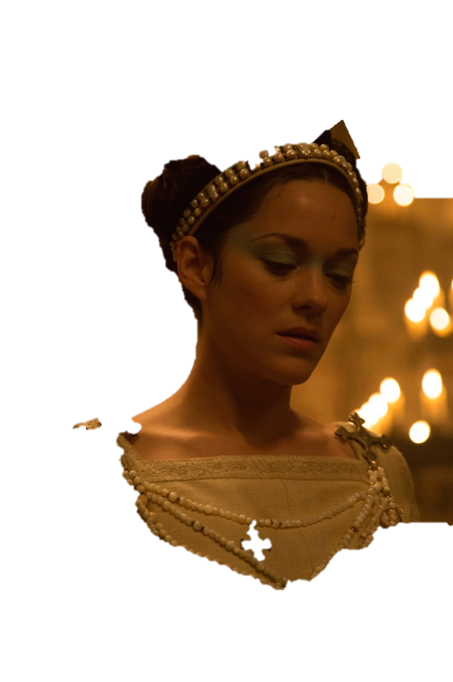

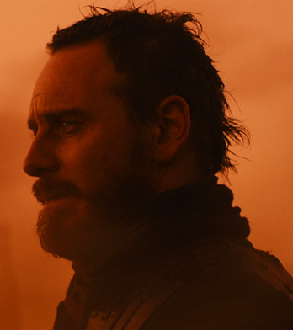

Use of emotive imagery
Assurance
Challenge questions:
Do you think Macbeth agrees to go ahead with the murder because he wants to or because his wife is so forceful in her arguments?
_________________________________________________________________________________________________________________________________________________________________________________________________________
What would a Jacobean audience have thought of Lady Macbeth?
_________________________________________________________________________________________________________________________________________________________________________________________________________
Reflection
Copy the following question into your formative assessment books and use the grid below to help you construct a response. What methods does Shakespeare use to present a persuasive and controlling Lady Macbeth at the end of Act One?

 | Technique | What technique has been used to present the Lady Macbeth’s controlling nature?
 | Example | Which line are you using as your evidence?  This is evident in the line…
 | Explanation | What does this line tell you about how Lady Macbeth attempts to persuade Macbeth? (Remember: dictionary definition explanation)  This line tells me…
 | Exploration | Focus in on the technique that has been used here. How does the use of this technique affect what we learn about Lady Macbeth and her ambition?  The use of ____ suggests…
 | Effect | What would an audience think as a result?  An audience would…

