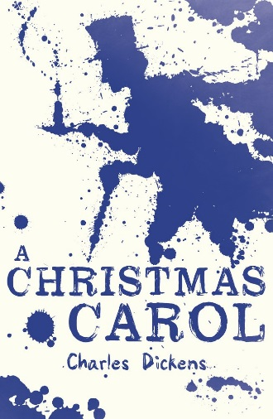
‘A Christmas Carol’ Quotation Revision

How can I learn quotations?
Remember, you can do this!
Revise, revisit and repeat
Use post it notes
Re-visit the texts - highlight
Start learning them early
Make/Do Quizzes
Create flashcards
Memorise them
Create Quote Posters
Repetition
‘A Christmas Carol’
Character | Link to quote, terminology and meaning
Scrooge  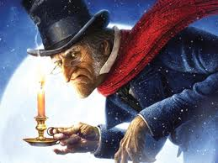 | - “squeezing, wrenching, grasping, scraping, clutching, covetous old sinner”  List to show he is obsessed with money – most actions are to do with the hand to show he was “tight-fisted”.  - “Solitary as an oyster”  Simile – to show how lonely and isolated he was  - “He carried his own low temperature around with him”  Metaphor – for his poor attitude and way he made others feel when he saw them.  - “Nobody stopped him in the street to say. ‘My dear Scrooge, how are you?’ ”  Metaphor – for his dislikeable and unfriendly character.  - “Bah! Humbug”  Exclamations – this is only repeated a couple of times but has become iconic as a representation of Scrooge’s dislike of spending and Christmas.  - “Every idiot who goes around with Merry Xmas on his lips... should be buried with a stake of holly through his heart”  Tone – shows how dislikeable Scrooge is and how much he hates Christmas as he has to stop making money for a day.  - “Are there no prisons? Are there no workhouses?”  Rhetorical Questions – suggesting the poor are at fault for having no money and that they have a place in society (even though we know prison and workhouses were terrible places)  - “If they would rather die, they had better do it and decrease the surplus population”  Metaphor – to show that poor people should die and free up space for other people and for making more money.  - “It’s not my business”  Tone – showing he isn’t interested in what happens to others.  THE CHANGE!  - “I will honour Christmas in my heart. I will live in the Past, the Present, and the Future. I will not shut out the lessons that they teach.”  Repetition – showing how he has had an epiphany and is no longer the miserly begrudging character he once was.  - “I am light as a feather, I am as happy as an angel, I am as merry as a schoolboy, I am giddy as a drunken man. A merry Christmas to everybody. Hallo! Whoop! Hallo!”  Repetition of the personal pronoun – shows his light hearted and carefree attitude and his lack of care about money and material goods.  - “I don’t know anything. I’m quite a baby.”  First person – Shows he is re-born as a decent person. Contrasts ‘old sinner’ in stave 1.  - “I’ll send it to Bob Cratchit!”  Statement – showing he is capable of charity by sending a decent goose to the Cratchit family.  - “Not a farthing less. A great many back payments are included in it.”  Short sentences – showing that Scrooge recognises that his wagers have been disproportionate and unfair to Bob.  - “I have come to dinner. Will you let me in Fred?”  Question – showing his uncertainty about his position with his nephew Fred due to the way he has always behaved in the past.  - “Therefore I am about to raise your salary!”  Emotive tone – showing he is being fair to Bob  - “Scrooge was better than his word. He did it all and became as good a friend, as good a master, and as good a man, as the good old city knew.”  Repetition – showing he is good to his word and that he became a different person.
The Ghost of Jacob Marley  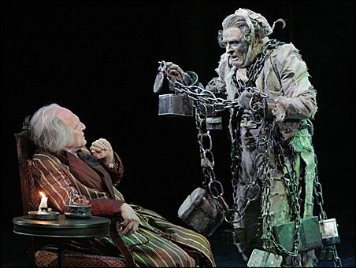 | - “On the very day of the funeral, (Scrooge) solemnised it with an undoubted bargain”  Negative tone – showing how Scrooge had already forgotten his friend and business partner.  - “I wear the chain I forged in life...The chain was made up of cash boxes...ledgers...heavy purses”  Metaphor – to show that the way he had behaved in life had a direct impact on him in the afterlife – he is now in purgatory and damned to walk the earth with heavy chains representing everything he valued in life  - “You may be an undigested bit of beef”  Metaphor – to show that Scrooge doesn’t really believe the spectral vision he is having at the moment.  - “My spirit never roved beyond the narrow limits of our money changing hole”  Metaphor – to show he was doomed in life due to his obsession with money and that this carries on in death too.  - “Mankind was my business!”  Symbolism – shows he understands the error of his ways and that money isn’t the be all and end all.
Bob Cratchit and Cratchit Family  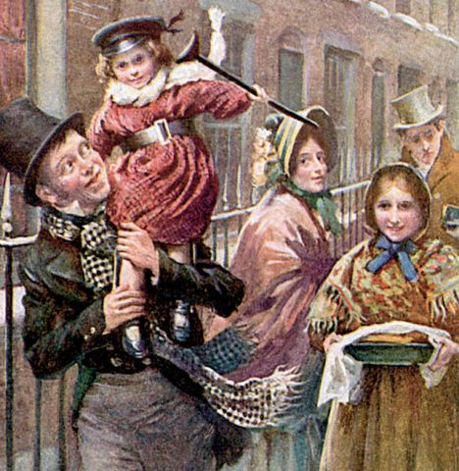 | - “The clerk’s fire was so very much smaller that it looked like only one coal”  Hyperbole – shows the terrible cold and conditions that Scrooge makes Bob work in.  - “There’s another fellow, my clerk with fifteen shillings a week, and a wife and family, talking about a merry Christmas. I’ll retire to Bedlam”  Statements – shows how little he pays Bob and how dismissive Scrooge is of his cheerful nature.  - “Tiny Tim hoped the people saw him in the church, because he was a cripple, and remember upon Christmas day, who made lame beggars walk, and blind men see.”  Religious connotations – Tiny Tim reinforces Christian values of charity, kindness and being thankful for what you have.  - “Mrs Cratchit made the gravy hissing hot, Master Peter mashed the potatoes with incredible vigour, Miss Belinda sweetened up the apple sauce...”  Listing – showing the family work together and that love is more important than money and materialistic goods.  - “There never was such a goose cooked.”  Hyperbole – showing they exaggerate the excitement of a goose which is too small for them as a family but they are grateful anyway.  - “Eked out by apple-sauce and mashed potatoes”  Adjective – shows that there isn’t enough food to go around  - “God bless us every one”  Religious Imagery – Tiny Tim again reinforces charity and peace and happiness to all mankind at Christmas time.  - “Mr Scrooge. I’d give him a piece of my mind. An  odious, stingy, hard, unfeeling man” (Mrs Cratchit)  Listing – the negative tone shows how unhappy she is with the way that Bob is treated by his employer.
Belle | - “Another idol has displaced me... a golden one”  Metaphor – to show that money has become more important to Scrooge than his fiancé Belle.  - “I have seen your nobler aspirations fall off, until the master passion, Gain engrosses you”  Triplets – to show her disappointment in the change in him.  - “May you be happy in the life you have chosen”  Statement – She wishes him luck and shows that she is leaving him due to his money grabbing ways.  - “No more! Show me no more!”  Repetition and imperatives – Scrooge can no longer watch his previous self and the loss of the love he had for Belle.  - “Now a comely matron sitting opposite her daughter”  Adjectives – shows how she is happily married and satisfied with her life but also highlights the happiness Scrooge has missed out on.
Fred – nephew of Scrooge  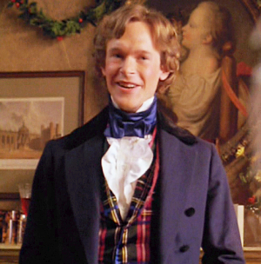 | - “What reason have you to be morose? You’re rich enough.”  Questioning – shows the difference in attitude between Fred and Scrooge and encourages Scrooge to be a happier more pleasant man.  - “I have always thought of Christmas as a good time, a kind, forgiving, charitable, pleasant time”  Listing – shows Fred’s love of Christmas and his clear difference in attitude to his uncle.  - “Don’t be angry Uncle. Merry Christmas!”  Short Sentences – showing that he is happy, like Christmas and charitable.  - “If you should happen, by any unlikely chance, to know a man more blest in a laugh than Scrooge’s nephew, all I can say is I should like to know him too.”  Narrative voice – reinforces how pleasant and nice Fred is.  - “Scrooge’s offences carry their own punishment. Who suffers? Himself!”  Dialogue – showing he understands that Scrooge is his own worst enemy.
Minor Characters:  Fan  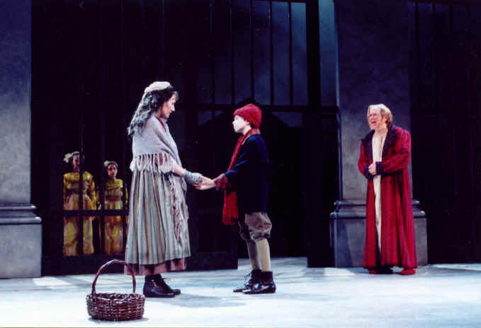  Fezziwig  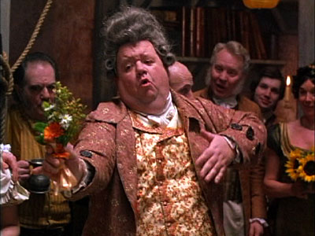  Mrs Dilber, the laundress and Joe  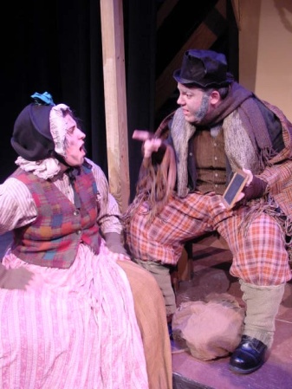 | - “I have come to bring you home dear brother... home, home, home!”  Repetition – showing that he was loved and loveable once but also reinforces the fact that his father didn’t want him around  - “You are quite a woman, little Fan”  Exclamation – showing he loved and admired his sister when they were young.  - “Bless his heart; it’s Fezziwig alive again!”  Happy Tone – showing that he has fond memories of his old employer.  - “Yo ho there! Ebenezer! Dick! No more work tonight!”  Jolly Tone – showing how charitable Fezziwig is by stopping them from working to have a Christmas Party.  - “He has the power to render us happy or unhappy; to make our service light or burdensome. The happiness he gives, is...as if it cost a fortune”  Epiphany – Scrooge realises that happiness doesn’t have to cost a fortune and that Fezziwig was a good employer.  - “Who’s the worse for the loss of a few things like these? Not a dead man I suppose.”  Dialogue – showing they don’t care about Scrooge and are happy to steal his possessions from him after his death.  - “He’d have had somebody to look after him when he was struck by Death, instead of lying gasping out his last there, alone by himself”  Dialogue – shows he died alone and unhappy.
The Ghosts  Ghost of Christmas Past  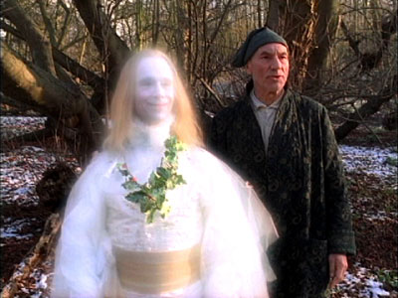 | - “Would you (Scrooge) so soon put out…the light I give?”  Metaphor – to show that the first ghost is there to illuminate his past and show him where things have gone wrong.  - “Scrooge was conscious of a thousand odours floating in the air, each one connected with a thousand thoughts and hopes and joys long long forgotten.”  Triplets – to show Scrooge once had dreams and thoughts and hopes like everyone else.  - “Strange to have forgotten it for so many years”  Statement – shows that Scrooge is not very reflective and doesn’t look back or try to adapt the way he is.  - “A solitary child, neglected by his friends, is left there still – Scrooge sobbed.”  Sibilance – shows how lonely Scrooge was as a child and the memory makes Scrooge unhappy as an adult.  - “To see Scrooge’s extraordinary voice between laughing and crying...and his excited face... would have been a surprise to his business friends in the city”  Emotive Language – shows that Scrooge is capable of emotion and that he isn’t heartless.  - “I should like to have given him (the boy carol singer) something: that’s all.”  First person – Scrooge thinks of someone kindly unlike his normal behaviour.  - “One child: true! your nephew!”  Exclamatory tone – the remembrance that he loved Fan (his sister) and he has neglected his duty as an uncle towards her son.  - (With Fezziwig) “Scrooge’s heart and soul were in the scene...he remembered everything, enjoyed everything.”  Repetition – shows Scrooge is capable of happiness or has been in the past.  - “A small matter to make these folks so full of gratitude”  Epiphany – shows that it is easy to make employees happy.  - “I should like to be able to say a word or two to my clerk just now. That’s all.”  Tone – shows that he is reflecting on his behaviour towards Bob.
Ghost of Christmas Present  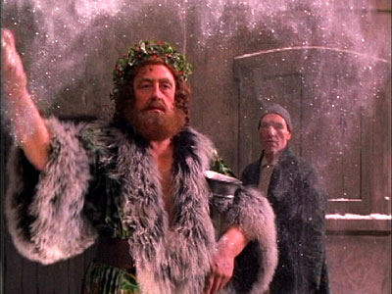 | - “A jolly giant who bore a glowing torch with a cheery voice and a joyful air”  Description – showing his benevolent nature  - “To a poor one most. Because it needs it most”  Repetition – to show the poor are in most need.  - “I see a vacant seat. The child will die”  Short sentences – emphasise the hole that would be left in the Cratchit family if Tiny Tim died.  - “Will you decide what men shall live, what men shall die? It may be in the sight of heaven, you are more worthless and less fit to live than millions like this poor man’s child”  Symbolism – The ghost is teaching Scrooge a lesson about humanity.  - “Scrooge was the ogre of the family and the mention of his name cast a dark shadow”  Hyperbole – showing how the rest of the family felt about Scrooge.  - “The numbers of people on the way to friendly gatherings”  Description – showing that even the poorest had love and friendship.  - “Even here... two men wished each other Merry Christmas in their can of grog.”  Symbolism – even in the lowliest of places people showed kindness and Christmas spirit.  - “Yes/No game... a disagreeable, savage animal. It’s Uncle Scro-o-o-o-ge!”  Adjectives – to show the family poking fun at Scrooge behind his back.  - “They are Man’s. This boy is Ignorance. This girl is Want. Beware for I see that written which is Doom.”  Symbolism – giving us a lesson about the nature of humans and the dark path that this will lead humanity down.
Ghost of Christmas Yet to Come  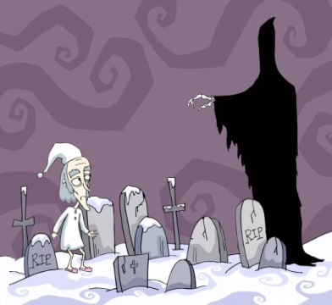 | - “It was shrouded in a deep black garment which concealed its head, its face, its form and left nothing visible except one outstretched hand”  Symbolism – describing the ghost like he is the grim reaper  - “Ghost of the Future. I fear you more than any spectre I have seen. But as I know your purpose is to do me good, I am prepared to bear you company with a thankful heart.”  Epiphany – Scrooge recognises that he needs to listen to the ghost and this is the first time that has happened.  - “I don’t mind going (to the funeral) if a lunch is provided.”  Emotive Language – showing that the businessmen don’t care that Scrooge is dead they are only after a free lunch.  - “Old Scratch has got his own at last hey?”  Rhetorical Question – showing his nickname isn’t particularly well respected.  - “So I am told... Cold isn’t it?”  Rhetorical question – others speaking about Scrooge with no feeling.  - “He frightened everyone away from him when he was alive, to profit us when he was dead, ha, ha!”  Mocking tone – showing that nobody cares about his death.  - “If there is any person in the town who feels emotion caused by this man’s death, show that person to me, Spirit, I beseech you!”  Desperate tone – Scrooge is begging the ghost to show someone will miss him.  - “It would be bad fortune to find so merciless a creditor. We may sleep tonight with light hearts, Caroline!”  Relieved tone – creditors of Scrooge are relieved they are not in debt to him any more as no one could be worse.  - “I am sure none we shall none of us forget Tiny Tim”  Repetition – grief at the death of Tiny Tim.  - “A churchyard, overrun by weeds, the growth of vegetation’s death not life –a worthy place!”  Triplets – showing nobody ever visited Scrooge’s grave or cared.  - “Scrooge crept towards it, trembling, and following the finger, read upon the stone of the neglected grave his own name, Ebenezer Scrooge.”  Complex sentence – reveals his emotion at seeing how little anyone cares for him or remembers him.

Each stave in three words:
Stave 1: Cold, selfish and message
Stave 2: Past, light and fear
Stave 3: Present, abundance, and family
Stave 4: Future, death and repentance
Stave 5: Joy, change and understanding
Characters:
Ebenezer Scrooge
- Represents the greed and selfishness of people in society
- Represents the people with the most power / money in society (old, white men) and the people with the power to make change
- Represents a conservative view – doesn’t want to change and so wants to keep things as they are
- Show how everybody has got the potential to change
- Shows how people will live unhappy lives if they don’t make sacrifices for others
- Opposite view to a Christian view of charity and kindness
- Represents a pessimistic and negative view of the world

Tiny Tim
- Represents the poor and poor children
- Embodies how poverty affects the most vulnerable in society
- Highlights how his fate is dependent on others in society
- Represents an extreme contrast to Scrooge – both opposite ends of the scale. One can’t survive without the other
- Symbolises a sympathetic view of the poor – a romantic view – innocent, undeserving person affected by poverty
- Symbolises the high infant mortality of London and urban regions
- Symbolises the future – if Tiny Tim and others like him die, then Scrooge and his kind will not have people to do his work for him

Bob Cratchit
- Represents the idea of the poor being respectable – people often saw that the poor were vermin or a drain on society
- Shows how the poor have dignity, respect and pride
- Highlights the importance of family and caring for our families
- A contrast with Scrooge – show us how to Scrooge should treat his family
- A symbol of Christmas – caring for each other
- Represents a positive and optimistic view of the world

Fezziwig
- Highlights how Scrooge’s past wasn’t negative
- A foil to compare Scrooge against – a business man who treats his employee respectfully
- A person who puts friends and family above his work
- Shows how someone should enjoy Christmas
- A symbol of the death of Scrooge’s happiness – Fezziwig died as did Scrooge’s happiness
- Represents a positive and optimistic view of the world
- A utopian view of the world – how inclusive society can be – all different types of people celebrating Christmas
- Exaggerated inversion of Scrooge

Cratchit Family
- Highlights the difficulty poor families faced in life
- Shows how the poor accepted their situation and tried their best to survive
- Symbolised how family was more important than money – a tough situation was bearable with loved ones around you
- Shows the potential in life – Scrooge has money, but no family – if he wasn’t the way he was, he’d have a family
- Shows the significance of family at Christmas
- Shows the significance of meals and eating as a family – coming together of people for one social event
- Symbolise the social aspects of the family and importance of connecting with people – sit in a ring

Ghost of Christmas Past
- Shows things haven’t always been so bad
- Show us what causes the changes in Scrooge
- Demonstrates to us that Scrooge has the potential to be good
- Shows us the importance of treating each Christmas as the last one – the loss of people cannot be recreated
- Symbol of aging and growing up – and the shortness of life (candle)
- Symbolises the impact our history has on our present
- Shows the importance of childhood and family relationships
- Shows us how we have a choice – follow love or follow money

Ghost of Christmas Present
- Symbolises how rich the present is – important and valuable
- Contrasts with the past and future – both cold and sad
- Shows how warm and friendly the present is – convincing us of the necessity to celebrate Christmas
- Shows us a variety of Christmas experiences – highlighting how Christmas is an experience that all share – rich or poor; young or old
- Links to the heat and cold – he brings warmth
- Reveals what people are really experiencing at Christmas – uncovers the truth

Ghost of Christmas Yet to Come
- Shows us the danger of Scrooge not changing his ways
- Symbolises the unknown aspect of the future (faceless and voiceless) – we don’t know what will happen in the future
- Traditional view of a ghost
- Shows us a negative view of the world
- Symbolises our fear of being forgotten and not leaving a legacy
- Plays on our fear of dying – it is inevitable, but we don’t like to be reminded of it

Poor / Rich
- We see negative and positive rich/poor characters, showing us the different types of people in society
- Dickens shows us how poor people survive – steal or work hard – very little choices
- The gentlemen from the charity highlight the hypocrisy of Victorian society – people thought that charity was enough to solve the problems
- Dickens show us through Tiny Tim’s fate how the rich and poor need each other – without they will fail / die
- Industrialisation made the rich richer and the poor poorer – made the gap wider

Ignorance and Want
- Both are presented as children – showing us how the young are the most important aspect of society – they are neglected here
- Ironic names – the rich focus on their ‘wants’ and our ‘ignorant’ to their influence, while the poor lack education and want things
- Dickens believed in the power of education – he felt that education was the key to improving society. If children were educated properly, then they could succeed
- Both characters are hidden from sight – the characters are hidden in under the clothes of Christmas Present symbolising how our focus on the present makes us forget those in need

Belle – fiancée
- Belle represents a time when Scrooge was happy
- She symbolises a choice between money and happiness – she offered him a choice and he chose money
- She represents rejection – and as she rejected him, he rejects all affection
- Symbolises the start of Scrooge’s journey into loneliness
- Two different versions of Bella – happy with Scrooge and happy not being with Scrooge
- Highlights how happy she is without him

Fred
- Shows how Scrooge’s cruelty is not a natural thing – it doesn’t run in the blood
- Contrast with Scrooge – shows us how someone should behave at Christmas
- Symbol of determination and positivity in the face of adversity
- Represents Scrooge’s link to humanity – through him he can be a normal person again
- Show us how family love in unconditional
- Symbolises the importance of family

Themes:

Isolation
- Emotional – Scrooge
- Physical – The Poor are separated from the poor – descriptions of the slums in Stave 4
- Enforced – Workhouses and Prisons mentioned in Stave 1
- Hot and cold used to highlight the different types of isolation – cold is usually associated with isolation
- Scrooge’s home represent isolation – different types – bed, bedroom, large house, empty street
- Family is often used in the story as the opposite of isolation
- The ghosts make sure Scrooge is not that alone in the story – they break the pattern

Choices
- Scrooge is responsible for the choices in the novella – he is in control of his world
- Scrooge is responsible for his current unhappiness – if he made the right choices, he would be happy now
- Scrooge has more choice than other characters because he has money – money gives you choice
- The key choice in the book is the choice between material goods or people
- Christian view of sacrifice and charity at the heart of the choices in the play

Family
- Two clear contrasting families – Scrooge / Cratchit (rich / poor)
- Happy events or positive moods occur when people are together as a family
- Family is linked to heat
- Family life is seen as healthy and good for you
- When Scrooge becomes part of a family, he becomes happy
- Scrooge cares more when he treats Bob and Tiny Tim as a family – an inclusive view of society – a responsibility to support one another
- Family accepts mistakes and past errors – Fred welcomes Scrooge back

Forgiveness / Compassion
- Starts with a lack of compassion – refusal to help charities; ends with compassion and charity – reversal
- Repeats the meeting with the men from the charities
- Challenges the hypocrisy of Victorian society – supposed to be Christian society, but the poor suffered terrible conditions which they were supposed to be grateful
- Story structured to understand and show compassion towards the poor – we are to understand that they don’t have themselves to blame for their circumstances
- The poor’s treatment at the hands of the rich is fixed in the story – shown how they can help

Settings
- Marley and Scrooge’s work place – cold place obsessed with making money and work
- Scrooge’s home – large, cold, rich empty
- Scrooge’s school – empty, neglected
- Fezziwig’s place – busy, warm, fun
- Cratchit’s home – busy, warm, barren
- Fred’s home – busy, warm, fun
- Belle’s home – busy, warm, friendly
- Pawnbrokers / Slum – dirty, cramped, cluttered

